
Capstone

Chaffey Cyber Hub Lab
Student Guide

Contents
Contents 1
Introduction 4
Weekly Schedule 4
Cyber Defense Class 4
Goal & Scope 5
Rack Layout 5
Simulators/Emulators 5
The Command Line Interface 5
Five Phases of the Pentest 6
Our Setup 6
Default Chaffey Password 6
Network Schema 7
Special Parts 7
Nightly Shutdown Procedure 8
Team Information 9
Discord Server 9
Team Assignments 9
Rack Documentation 9
Goal 1: Prepare the Switch 11
Task 1: Reset to Factory Default Settings 11
Task 2: Assign a Static IP to VLAN1 and the OOB Port 12
Goal 2: Setup Firewall 12
Task 1: Connect to Firewall using SSH and Reset 12
Task 2: Configure The Firewall Basics 13
Task 3: Backup Configuration 14
Task 4: Configure Interfaces: WAN 14
Task 5: Configure Interfaces: LAN 15
Task 6: Configure the Default Route 15
Task 7: Configure your First Policy 16
Task 8: Configure Other Policies 17
Task 9: Configure Firewall for Outbound Ping 17
Task 10: Configure firewall for Outbound Ping to a Single Device 17
Task 11: Disable Ping Response from The Firewall 17
Task 12: Add an Access Control List: Block Traffic from an IP 18
Task 13: Configure a Virtual IP 19
Task 14: Add Other VIPs 20
Task 15: Add VIP Group 20
Task 16: Add VIP for Ping 20
Goal 3: Setup Web Server 21
Goal 4: Setup Network Switch 21
Task 1: Connect to the Switch 21
Task 2: Access the Web Interface 21
Task 3: Save and Back Up Configuration 21
Task 4: Services 22
Task 5: VLAN Setup 23
Task 6: DHCP 27
Goal 5: Hypervisor Host & Virtual Machine Setup 28
Task 1: Create an Image 28
Task 2: Configure ESXi 33
Task 3: Setup Ubuntu VM 33
Task 3 Set up a Target FTP Server 41
Task 4 Setup Vulnerable Pi 42
Task 5: Sniff & Analyze Traffic 42
Goal 6: Scan Another Team’s Infrastructure 42
Task 1: Install Greenbone and Run a Test Scan 42
Task 2: Scan Another Team’s Infrastructure 42
Goal 7: Tools of the Trade 43
Goal 8: Expanded Cyber Range 43
Task 1 Setup Windows Services 43
Task 2 Setup Unix Services 44
Task 3: Setup OWASP web server 46
Task 4 Setup Mobile & IOT Devices 46
Task 5: DMZ Setup (Extra Credit) 47
Task 6: VPN (Extra Credit) 47
Task 7: VPN with 2 factor authentication (Extra Credit) 47
Task 8: Expanded Scan of Your network. 47
References 48
Contributors / Testers 48
Change Log 48

Introduction
Our objective is to build a controlled lab environment for learning and practicing cybersecurity skills without exposing campus networks to potential risks.
Important: Never install malware or connect unauthorized devices to the campus network.
This lab environment aims to:
- Simulate a real-world working environment.
- Provide hands-on experience with tools, skills, and demonstrations.
- Enable students to build a mock production environment.
- Develop students’ technical writing skills, as requested by the CIS Advisory Committee, which includes industry partners from the Inland Empire.
Students will be instructed to complete specific tasks using the appliance GUI (Graphical User Interface) and then determine the necessary command-line equivalents for the same tasks. For instance, if the task involves backing up a device using the graphical backup button, students must identify the corresponding commands, document them in the lab assignment, and include screenshots showing the completed task on the device.
Weekly Schedule
This is a general overview of our schedule and is subject to change. If there is time we will start the optional Goal 8 additions.
Week | Goal Number | Learning Objective
1 | N/A | Course Intro, Form Teams & Rack Familiarization
2 | N/A | Rack & Stack
3 | N/A | Connect to Equipment Familiarization & NCL Familiarization
4 | Goal 1 Tasks 1 – 2 | Preparing the Switch
5 | Goal 2 Tasks 1 – 6 | Setup Firewall
6 | Goal 2 Tasks 7 – 12 | Configure Default Route and Policies
7 | Goal 2 Tasks 13 – 16 | VIPs & VIP Groups
8 | Goal 3 & Goal 4 Tasks 1 – 3 | Web Server & Setup Network Switch
9 | Goal 4 Tasks 4 – 5 | Setup Switch VLANs
10-11 | Goal 5 Tasks 1 – 3 | Hypervisor & Virtual Machine Setup
12 | Goal 5 Tasks 4 – 5 | Setup Vulnerable Pi and Analyze Traffic
13 | Goal 6 Task 1 | Setup Kali, Greenbone
14 | Goal 6 Task 2 | Conduct Engagement with Another Team
15-16 | Goal 7 | Tools of the Trade
17 | Goal 7 | Demonstrate Tools to Class

Cyber Defense Class
Your network will emulate the five stages of a successful cyber-attack and defense to protect systems within it. To create a realistic organizational environment for attack simulations, you must apply the skills you learned in previous classes to set up the infrastructure. In earlier classes and in NetLabs, everything was preconfigured for you—your task was simply to follow the instructions. However, the real world involves conflicts, dependencies, misconfigurations, and other challenges. You might be given a task and expected to complete it without a step-by-step guide. For example, "We need a server to track network activity; John and Jane, please set it up on network X and provide all relevant documentation to Team B via a syslog system."
This lab manual is designed to replicate such real-world scenarios.

Goal & Scope
Students will receive instructions to set up a basic enterprise network with foundational security, including services and routing. After getting the network up and running, students will be assigned specific tasks to complete independently, without instructor assistance. The goal is to collaborate across teams to achieve the objectives.

Rack Layout
Our rack is a NetShelter by APC, and its layout is as follows:
U# | Make | Model
24 | Tripp Lite | B040-008-19
23
22
21
20
19
18 | Dell | PowerEdge R420
17
16 | Dell | PowerEdge R440
15
14 | Cisco | CBS350-12XT
13
12 | Cisco | CBS350-12XT
11
10 | Fortinet | FortiGate 50E
9
8 | Netgate | Fortinet | SG-3100 | FortiWIFI 60E
7
6 | Dell | PowerEdge R440
5
4 | Synology | RS816
3
2 | Startech.com | SLIDESHELFD
1 | Tripp-Lite | SMART750RM1U
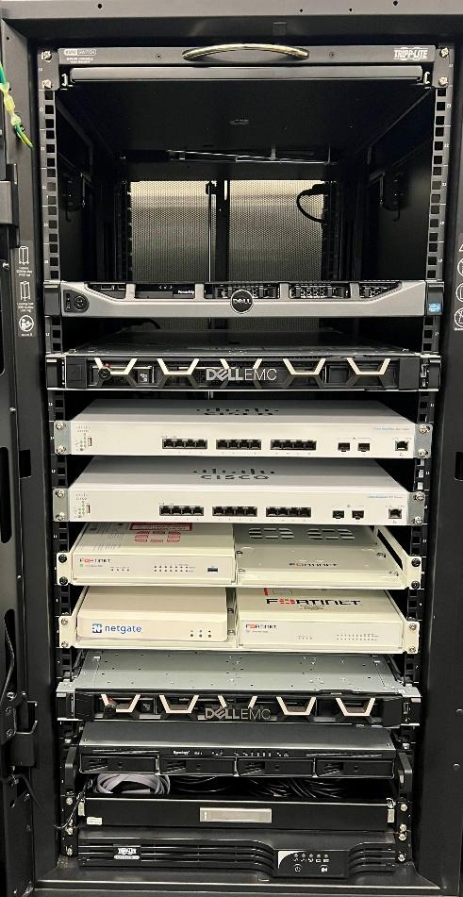

Simulators/Emulators
Access these simulators/emulators to practice in a test environment:
FortiGate: https://Fortigate.fortidemo.com/logindisclaimer (username/password is “demo”)
Cisco Business Switch: Online Device Emulator
Synology: https://demo.synology.com/en-us/dsm
VMWare (requires account creation): https://www.vmware.com/try-vmware/try-hands-on-labs.html

The Command Line Interface
The command line interface, known as the CLI, has a different syntax for each device. Use the following references to research CLI commands for our switch and router:
Cisco Business Switch 350 CLI Index: https://www.cisco.com/c/en/us/td/docs/switches/lan/csbms/CBS_250_350/CLI/cbs-350-cli-/cbs-350-cli-_CLT_chapter.html
Fortinet CLI Reference: https://help.fortinet.com/cli/fos60hlp/60/index.htm

Five Phases of the Pentest
The five phases of a penetration test are:

- Reconnaissance – Gathering as much information as possible about the target to identify potential vulnerabilities.
- Scanning – Using tools to map the network, identify open ports, and detect exploitable systems or services.
- Access – Gaining unauthorized access to the system. This phase includes:
a. Escalation – Elevating privileges to gain higher levels of control.
b. Exfiltration/Assault – Extracting sensitive data or executing planned attacks.
- Sustainment of Access – Maintaining access to the target system for long-term exploitation without being detected.
- Obfuscation / Covering Tracks – Removing evidence of the breach and hiding activity to prevent detection and ensure anonymity.

Understanding these phases is crucial for a career in cybersecurity, as they are foundational for industry certifications and will also be covered on the final exam for this class.

Our Setup
You will set up an enterprise network that will connect to the instructor rack and other teams creating a pseudo internet. You will then attempt the 5 phases of Cyber Defense to gain root access into another team’s systems.
In this semester, depending on the speed of the class, you will:
- Rack and stack equipment.
- Research procedures to reset each device back to manufacture system default.
- Setup Cisco switch.
- Setup Fortinet Firewall.
- Setup ESXi on a flash drive.
- Setup a web server on a Raspberry Pi.
- Provision drive space on ESXi system for servers and connect using the web client.
- Setup an Ubuntu VM.
- Setup a Kali VM and install Greenbone.
- Configure a vulnerable Raspberry Pi using RasPwn OS.
- Setup NetGate.
- Setup Snort on NetGate.
- Setup Microsoft VMs.
- Setup Services:
  - Active Directory
  - DHCP
  - DNS
- Add Windows VM Client to AD.

Default Chaffey Password
All devices have a default password which we will need to change. Use the following password for every device or operating system:
1Panther_Geek
Typically, you should not set the same password for all devices, but this is a learning environment so for consistency, ease of access, and troubleshooting, the use of a single admin password is important.

Network Schema
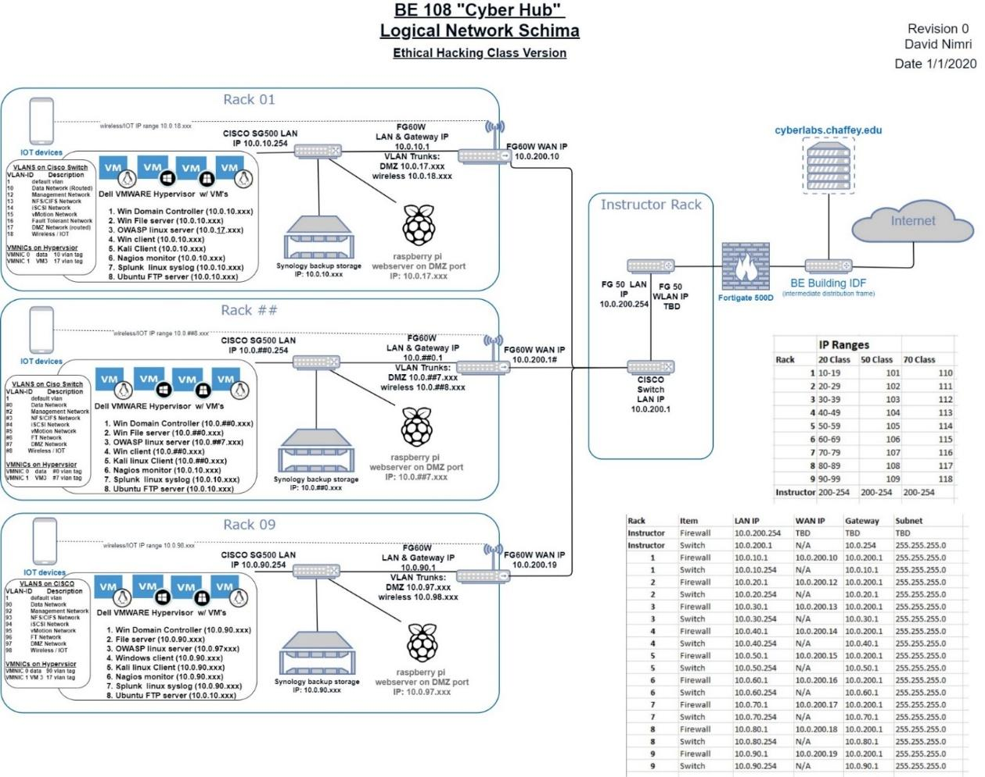
You can download a high-resolution version of this schema on Canvas.
Note that there may be some differences in the guide. The schema reflects our initial design for this class. When in doubt, use the instructions and not the image.

Special Parts
These parts can be found on the shelf above the UPS.
Multiport Dongle: Used to connect your laptop to the network via ethernet for your router or switch. Each dongle is specific to the rack and laptop. Note that the multiport dongle NIC will always receive its IP address via DHCP if you are using the classroom supplied laptop.
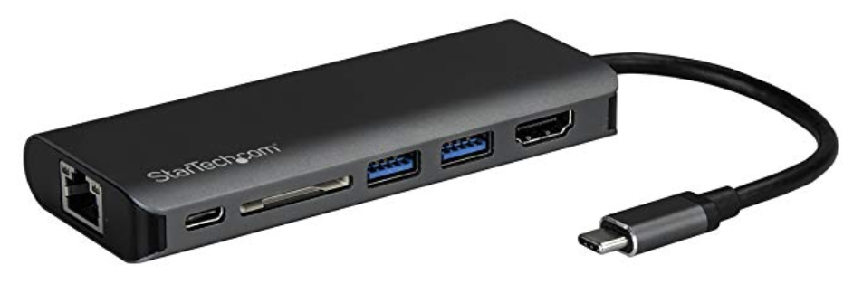
USB/Console Adapter: Creates a virtual COM port to connect to your firewall and switch using PuTTY.
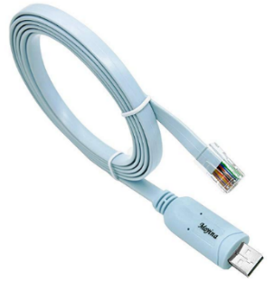
Tripp Lite KVM: Enables a direct connection to the rackmount KVM.
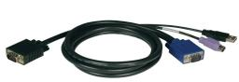

Nightly Shutdown Procedure
Following these steps ensures proper shutdown, organization, and safety of equipment while maintaining a tidy workspace for future use.
- At the ESXi menu, press F12, enter the password, press space to forcefully terminate running VMs, and then press F2.
- Turn off the KVM switch, fold it, and slide it into the rack.
- Power off the UPS by holding the power button, which will turn off all connected appliances.
- Make sure all cables are neat. You can leave them plugged in if you’re going to work on the same device the following class.
- Unplug the power, wrap the cable and place it on the shelf.
- Call the instructor to review your rack.

Team Information
Team Name: ATNT
Team Color: Green
Team Rack Number: Rack 3
Competitor: BlackBoxOps
Team Logo: 

Discord Server
Consider creating a Discord server for your team to communicate and share files or screenshots efficiently. If you don’t already have a Discord account, you can create one at https://discord.com/.

Team Assignments
A cohesive IT team comprising a security analyst, network administrator, systems administrator, DevOps/SysOps professional, and audit/documentation lead collaborates to safeguard, optimize, and maintain systems, networks, and processes while ensuring compliance and operational efficiency.

Choose a member for each role:

Security Analyst: TB
- A security analyst identifies, monitors, and mitigates security threats to protect an organization’s systems and data.

Network Admin: CJ
- A network administrator manages, maintains, and optimizes an organization's network infrastructure to ensure seamless communication and connectivity.

Systems Admin: KC
- A systems administrator is responsible for the configuration, maintenance, and reliable operation of computer systems and servers.

Dev/SysOps: Najee Gaston
- A DevOps/SysOps professional bridges development and operations by automating processes, managing deployments, troubleshooting, and, specifically in our case, looking up CLI commands.

Documentation and Audit Lead: Najee,C,K
- An audit and documentation lead ensures compliance by managing documentation, conducting audits, and maintaining records of processes and controls.

Rack Documentation
Keep this section updated as you complete your goals, as you will refer to it frequently.
- Switch Information
  - Username: Cisco
  - Password: 1Panther_Geek
  - Switch Management IP: 10.0.30.254
  - Data Network VLAN IP: 10.0.31.254.
  - Management VLAN IP: 10.0.32.254
- Firewall Information
  - Username:admin
  - Password: 1Panther_Geek
  - WAN1 IP: 10.0.200.13
  - LAN IP: 10.0.30.1
- Other Information
  - Instructor Gateway IP: 10.0.200.1
  - FTP Server IP: internal-10.0.30.13; External-10.0.200.13
  - SSH Server IP: internal-10.0.30.2; External 10.0.200.23
  - Web Server IP: internal-10.0.30.33; External- 10.0.200.33
  - ICMP IP: internal-10.0.30.43 ; External - 10.0.200.43
  - ESXi IP: 10.0.32.52
  - Vulnerable Pi IP: 10.0.30.25

Goal 1: Prepare the Switch
Task 1: Reset to Factory Default Settings
You will need to reset the switch to factory default settings so that no previous rules, policies, or information conflict with the new setup.
Our first step is to connect to the switch console port and start PuTTY.
Please note, your COM port number will vary from computer to computer. Once you plug in your USB/console cable, check Device Manager.
What is your Switch COM port number? COM3
Use the following settings for PuTTY:
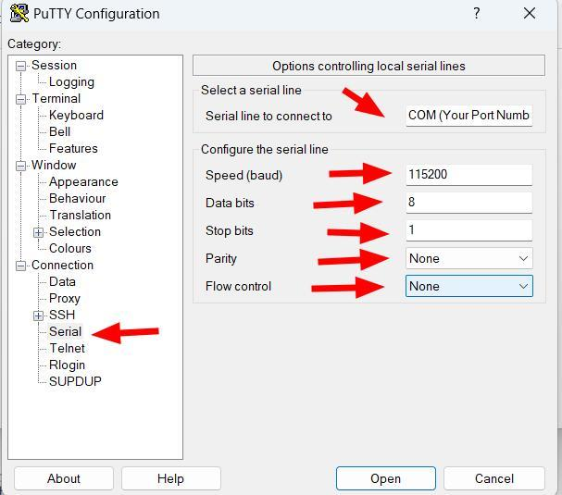
Save this configuration.
Now click Open, hit enter twice, and log in:
Default Username: cisco
Default Password: cisco
You will be prompted to change the username and password. Use cisco and 1Panther_Geek:
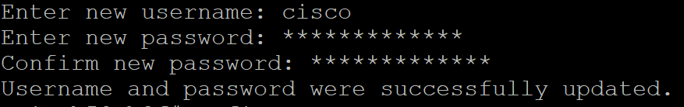
To reset the switch, we need to remove the current startup configuration.
Research and use the command to delete the startup config. Afterward, research and use the command to reload/reboot.

Task 2: Assign a Static IP to VLAN1 and the OOB Port
Assigning a static IP to VLAN1 and the OOB port ensures consistent network connectivity and easier management by preventing IP address changes.
Log back in, you’ll be prompted to change the username and password again.
Now type config to enter the Global Configuration mode.
Our goal is to assign a static IP address for the default VLAN1.
Research and use the command to enter the Interface Configuration Mode for VLAN1 (hint: it starts with “interface”).
Now we can change the IP address based on our network schema. Remember our IP schema corresponds to our rack number. For example, Rack 9 would use 10.0.90.254:
Use the command end to save your changes.
You can confirm the IP change using the command show ip interface:
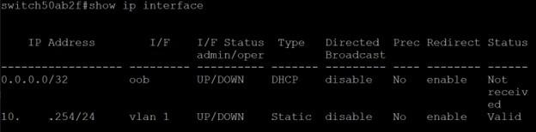
Save this new configuration by researching the command to copy the running configuration by overwriting the startup configuration.
Repeat these steps to assign the static IP 192.168.1.254 to the OOB port. Remember to save the running configuration again.
The OOB (Out-of-Band) port is a dedicated management interface that provides secure, isolated access for configuring and troubleshooting the switch independently of the main data network. It is particularly useful when the primary network is down or experiencing issues, allowing administrators to access the switch for diagnostics and recovery without relying on the affected network.
Note the IP addresses, username, and password in the Rack Documentation section.

Goal 2: Setup Firewall

Task 1: Connect to Firewall using SSH and Reset
Connect the USB/Console cable to the FortiGate console port. Note: Like the switch, your COM port will vary from computer to computer.
Now, start PuTTY and configure as follows:
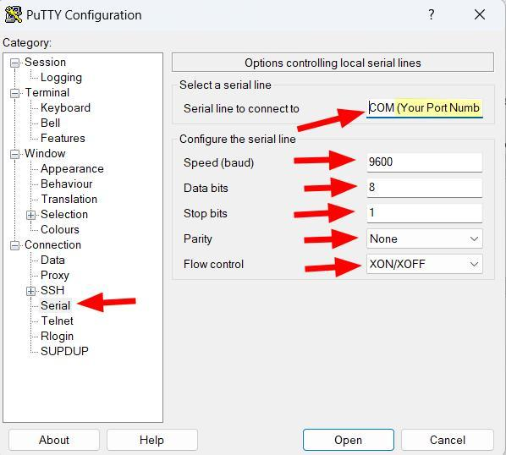
Save this PuTTY session so you can return to it later.
Open your newly configured firewall console session.
At the login prompt, type admin for the username. There is no password so simply hit enter again.
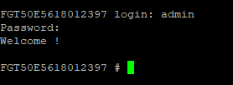
Now research and input the command to execute a factory reset.
Reboot, then connect your laptop to the firewall using the USB ethernet hub and any numbered ethernet port.
The default IP for the firewall will be: 192.168.1.99. Navigate to that IP address and ignore the warning.
If successful you will see the web interface log in screen:
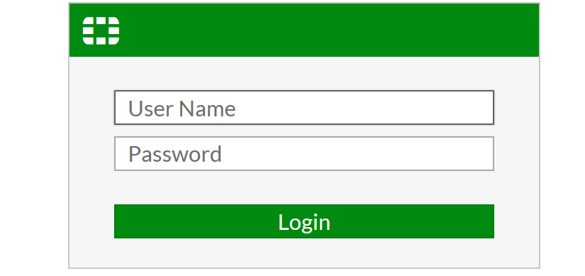
If you cannot access the web interface, check the basics: ensure everything is properly plugged in and configured. Re-read the guide and troubleshoot as needed.

Task 2: Configure The Firewall Basics
Our task in this section is to update the firewall admin password and configure NAT/Route mode. This mode enables the Fortinet firewall to serve as an intermediary between the internet or campus network and your private network. It conceals all internal network IP addresses while routing requests from devices behind the firewall to the internet or campus network.
At the firewall GUI login, enter the username admin and leave the password blank.
Once Prompted, change the password to: 1Panther_Geek
Note this in the Rack Documentation section.
CLI to accomplish this task:
config system admin
edit admin
set password 1Panther_Geek
end
exit
https://help.fortinet.com/fweb/582/Content/FortiWeb/fortiweb-admin/password.htm

Task 3: Backup Configuration
To back up the configuration, click on the admin menu in the top right-hand side and backup to Local PC.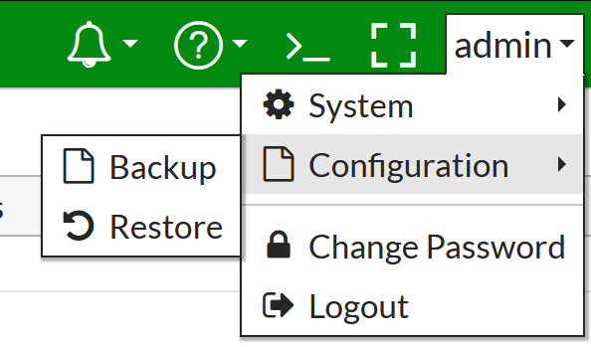
You should do this step before EVERY major task.
CLI to accomplish this task: execute backup all-settings

Task 4: Configure Interfaces: WAN
Navigate to Network 🡪 Interfaces, select the WAN1 interface, and click Edit. Set the address to Manual and configure the following IP address for the WAN1 interface: 10.0.200.1# (adjust according to your specific network schema).
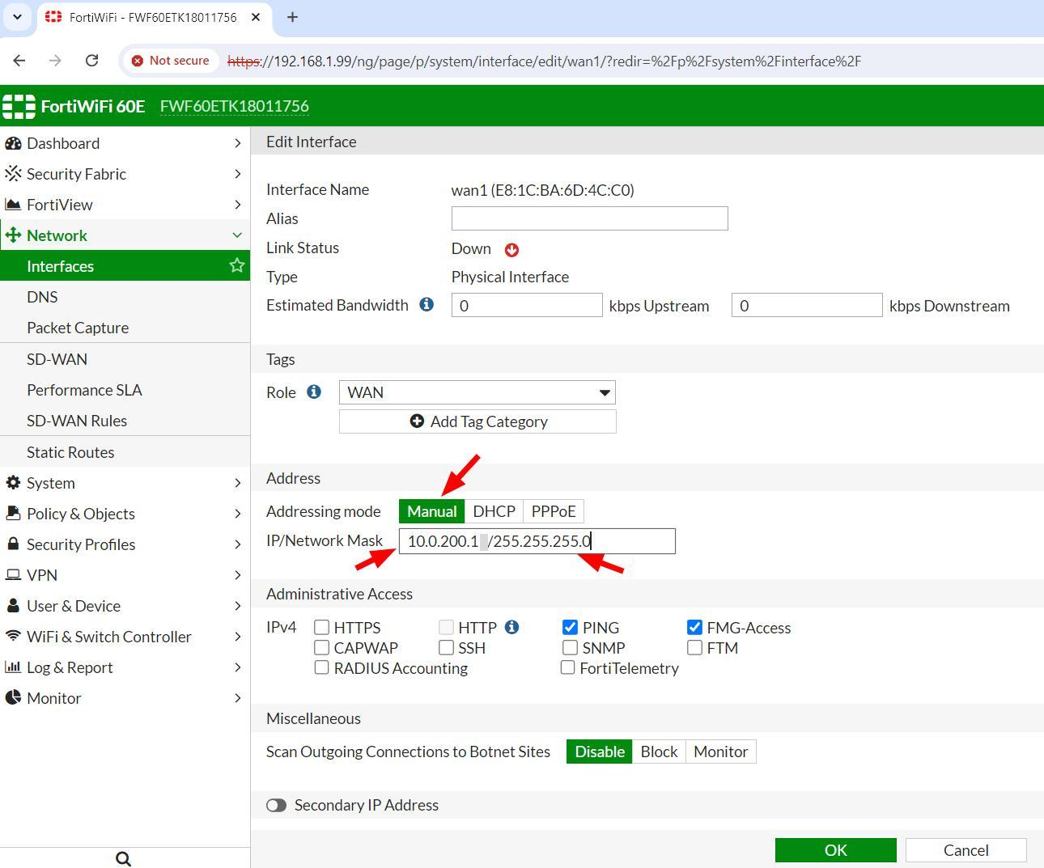
What is your firewall WAN1 IP address: 10.0.200.13 /255.255.255.0

Note this in the Rack Documentation section.
CLI to accomplish this task:
config system interface
edit “lan”
set mode static
set ip 10.0.200.13 255.255.255.0
https://docs.fortinet.com/document/fortigate/7.2.3/cli-reference/9620/config-system-interface

Task 5: Configure Interfaces: LAN
Navigate to Network 🡪 Interfaces and select the LAN interface, then click Edit. In the Address section, select Manual and assign the internal IP address for your firewall (e.g., 10.0.#0.1):
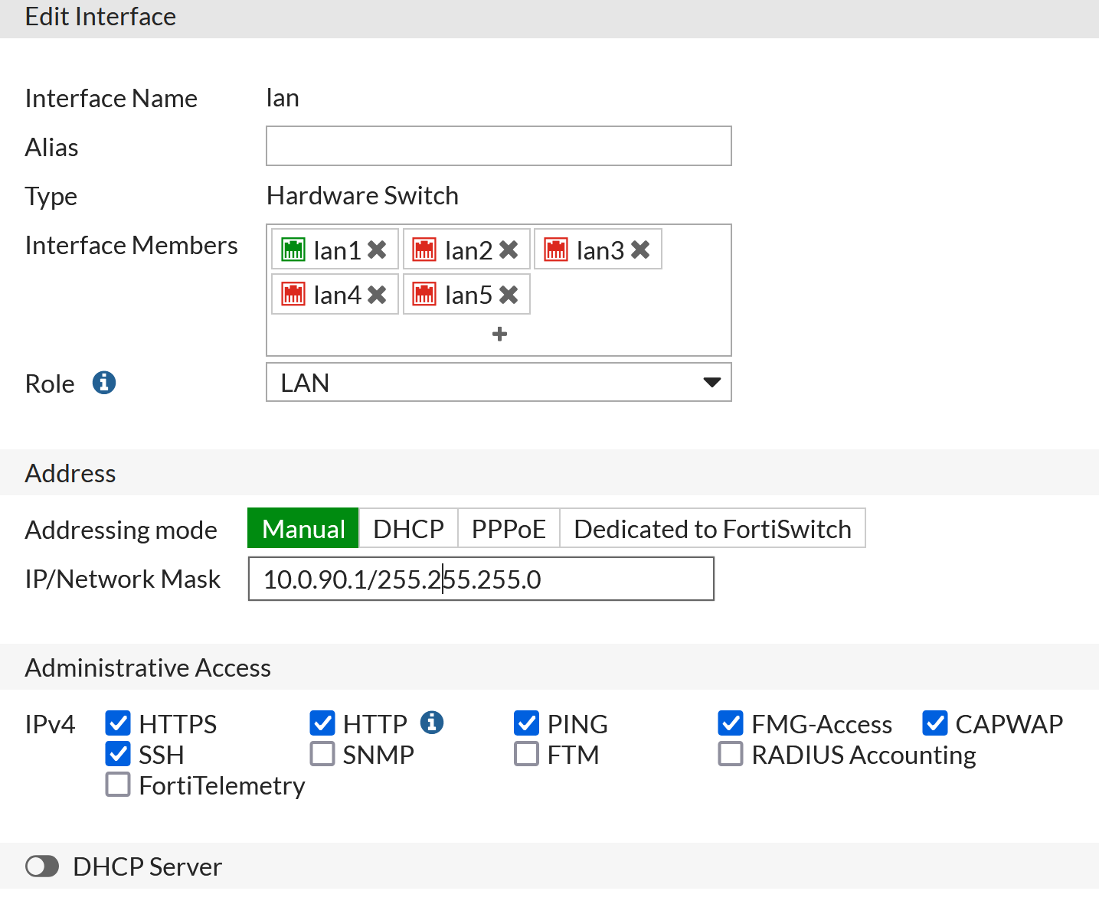
What is your firewall LAN IP address: 10.0.30.1 /255.255.255.0
Show this to your instructor before proceeding.
Note this in the Rack Documentation section.
Once you get approval, click apply. From here on you will connect to the firewall web interface with the new internal IP address you assigned.
CLI to accomplish this task:
config system interface
edit “lan”
set mode static
set ip 10.0.200.13 255.255.255.0

https://docs.fortinet.com/document/fortigate/7.2.3/cli-reference/9620/config-system-interface

Task 6: Configure the Default Route
A default route defines packet forwarding rule when no specific route can be determined for a destination IP address.
Click on Network → Static Routes → Create New.
Use the following settings:
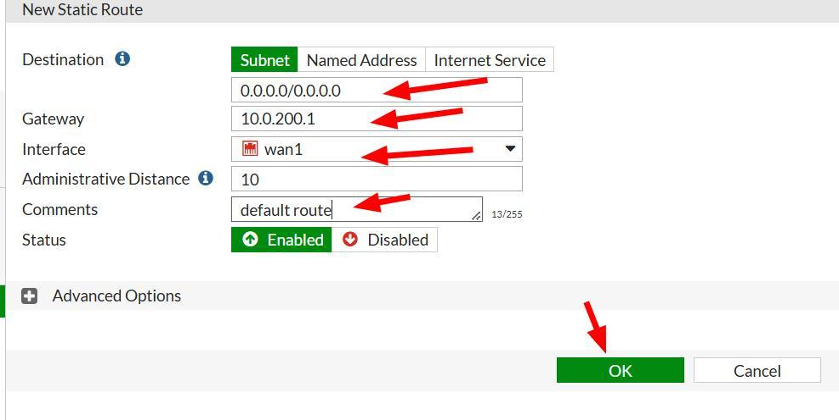
Why is the default route 0.0.0.0/0.0.0.0 (0.0.0.0/0 in CIDR)? It matches all addresses in the ipv4 address space and is present on most host.
CLI to accomplish this task:
config router static
set dst 0.0.0.0 0.0.0.0
set gateway 10.0.200.13
set device wan1
https://docs.fortinet.com/document/fortigate/7.2.3/cli-reference/570620/config-router-static
Save your configuration.

Task 7: Configure your First Policy
Our next goal is to create firewall policies and rules.
A firewall policy defines what traffic the firewall allows or blocks. It uses firewall rules, which provide specific instructions for overseeing distinct types of traffic. For example, a policy might block all incoming traffic except for traffic on port 80.
Our first rule will allow internet traffic through the FortiGate:
- Navigate to Policy & Objects 🡪 IPv4 Policy and click Create New.
- Set the following parameters:
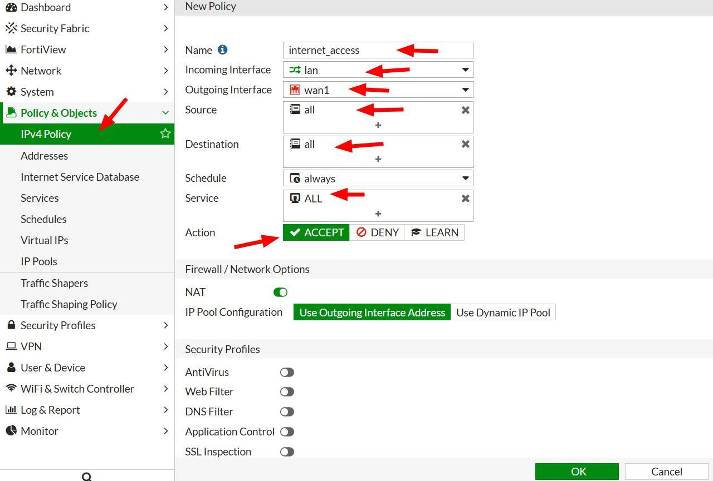
Click ACCEPT to save the policy.
CLI to accomplish this task: config router policy
config firewall policy
set interface lan
set dstaddr wan1
set source all
set destination all
set service All
set action accept
set status enable

https://docs.fortinet.com/document/fortigate/7.2.3/cli-reference/323620/config-firewall-policy

Task 8: Configure Other Policies
Your goal is to ping the gateway connected to your network, located in the instructor's rack, which simulates an ISP-provided internet uplink.
Log into the FortiGate and click on the CLI icon in the top right-hand side:
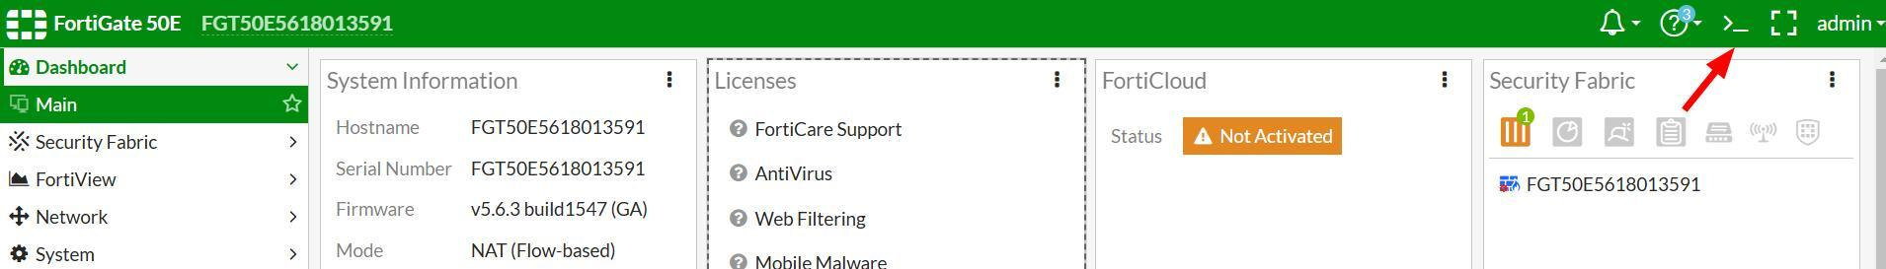
In the command prompt type: Exec ping: 10.0.200.1
Was the ping successful? Yes
Why or why not?It worked because it was set up properly and it was on the network.

Task 9: Configure Firewall for Outbound Ping
Figure out, based on what you learned so far, how to add an IPv4 policy rule to allow all systems to ping from within your firewall out to the instructor provided gateway. Ping is an echo/response command.
What protocol is Ping part of? Ping is part of protocol ICMP.
CLI to accomplish this task:
config firewall policy
set name”Allow_one_ping”
set srcintf “internal”
set dating “wan2”
set srcaddr “all”
set dstaddr ””
set action accept
set schedule “always”
set service “PING”
set logtraffic all
https://docs.fortinet.com/document/fortigate/7.2.3/cli-reference/323620/config-firewall-policy
Solution screenshot (configuration page): 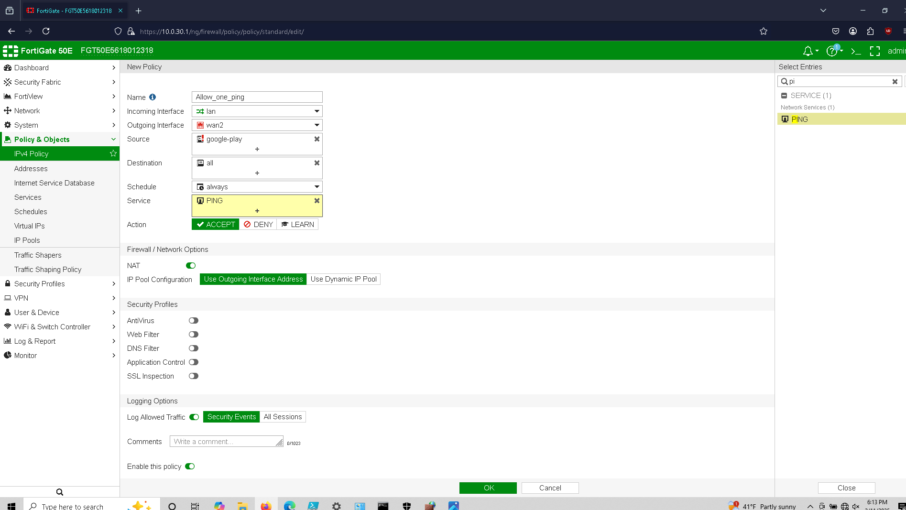
Results screenshot (successful ping): 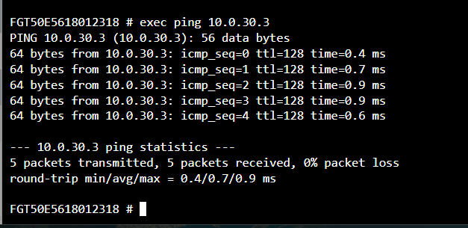

Task 10: Configure firewall for Outbound Ping to a Single Device
Figure out, based on what you learned so far, how to add a policy rule to allow a single system to ping from within your firewall out to the instructor provided gateway.
Provide your configuration file and screen shots.
CLI to accomplish this task:
config firewall address
set subnet 10.0.30.10 255.255.255.0
https://docs.fortinet.com/document/fortigate/7.2.3/cli-reference/254620/config-firewall-address
Solution screenshot (configuration page): 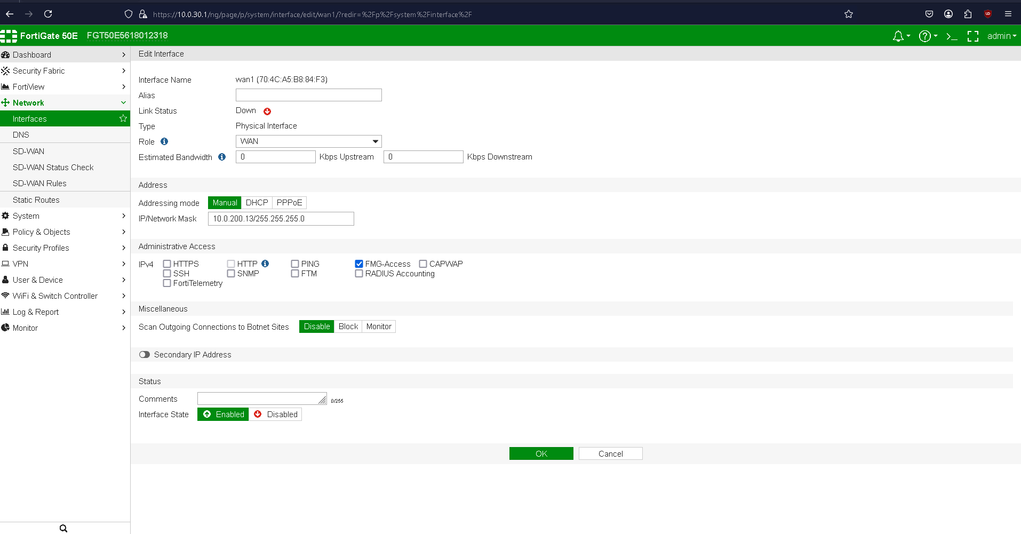
Results screenshot (successful ping): 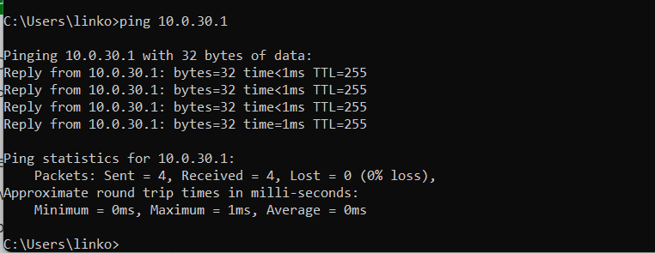

Task 11: Disable Ping Response from The Firewall
Click on Network, Interfaces, WAN1 and click “Edit.”
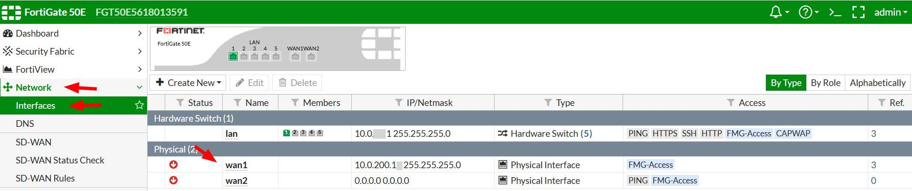
Under Administrative access, uncheck ping and click ok.
Try to ping your firewall from your laptop.
Did it work? No it does not work.
Why or why not? The ability to ping was turned off and so the request will be blocked by the firewall.

Task 12: Add an Access Control List: Block Traffic from an IP
Adding an IP to the denylist will prevent anyone in the network from accessing it. We will deny an IP address that is known for spam as reported by snort.org & CISCO Talos:
80.85.153.246
Click on Policy & Objects → Addresses, click on Create New then Addresses:
Put in the following configuration but replace with your initials:
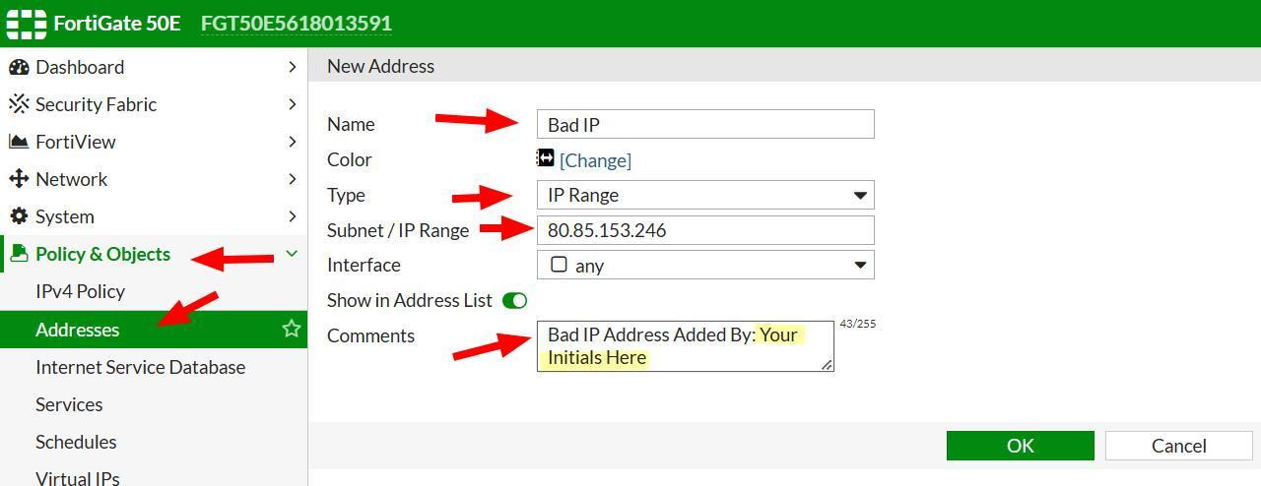
Provide screenshot of your address settings: 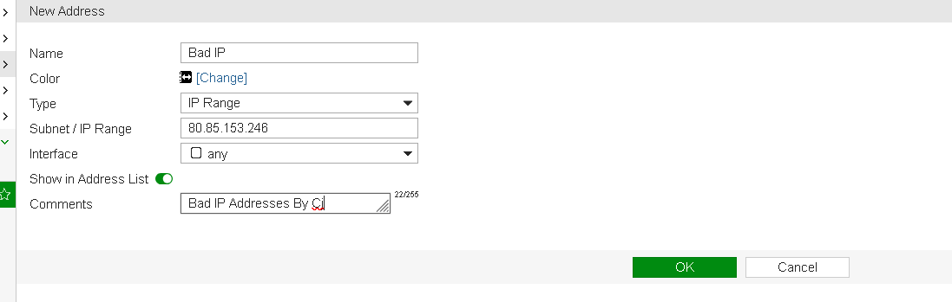
Click on IPv4 Policy under Policy & Objects then click Create New:
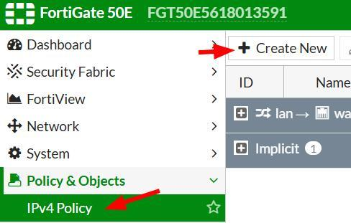
Set the following settings to DENY, and click OK:
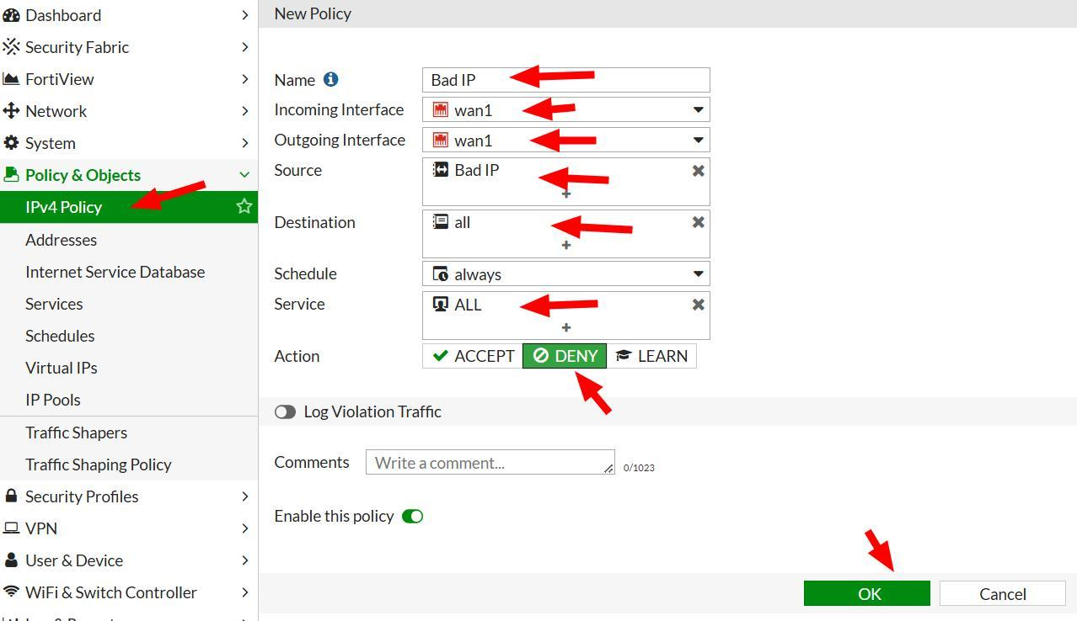
Provide screenshot showing in the IPv4 Policy List showing its denied: 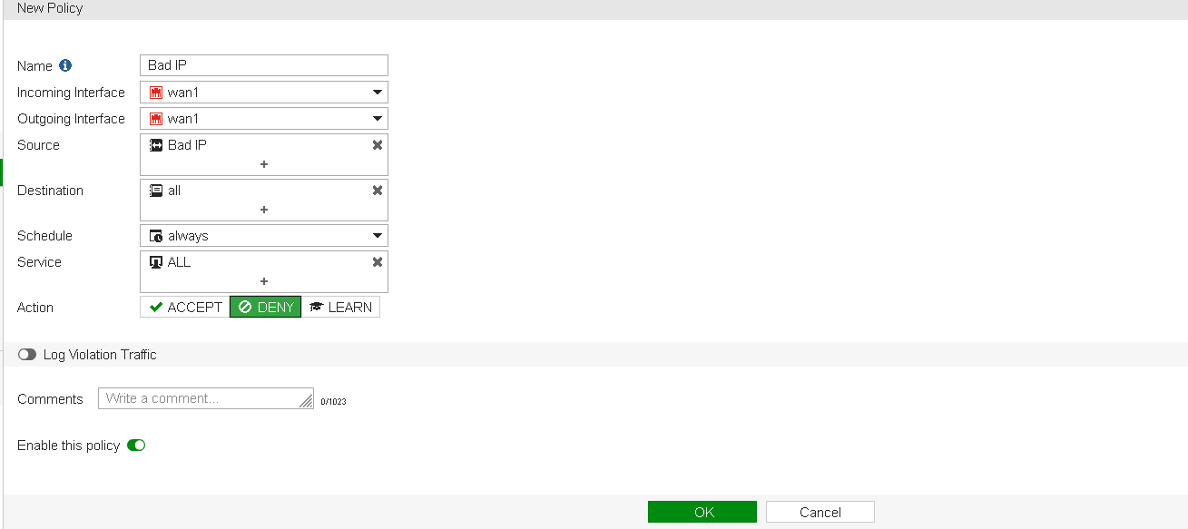

Task 13: Configure a Virtual IP
Give the definition of a Virtual IP (VIP) and its purpose: A virtual ip is a non-physical ip address, designed to connect ports and systems to logic networks. If you have a printers on ports, instead of manually unplugging them and putting them on one switch, you can just create a VIP and groups those together as printers.
Decide on an IP address within your subnet following the network schema:
- FTP Server IP: 10.0.30.13(internal; External-10.0.200.13
- SSH Server IP: internal-10.0.30.2; External 10.0.200.23
- Web Server IP: internal-10.0.30.33; external- 10.0.200.33
- ICMP IP: internal-10.0.30.43 ; external - 10.0.200.43
Note this in the Rack Documentation section.
Now we will add a rule to allow traffic for FTP to the server in your ESXi environment.
Go to Virtual IPs, provide a meaningful name, select WAN1 interface, set the external IP of your firewall, the internal IP of your FTP server in your ESXi environment, set port forward, and select port 21 for external and map port click ok.
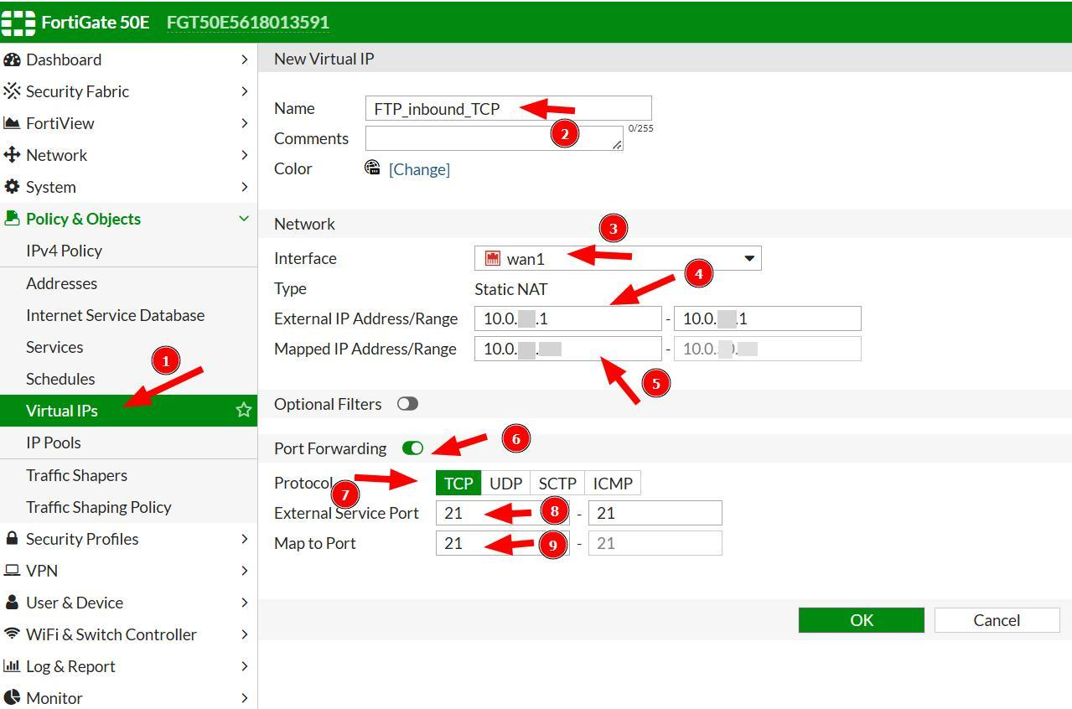
CLI to accomplish this task:
config firewall vip
set exitip 10.0.200.13
set extintf “wan1”
set mappedip 10.0.30.13
set portforward enable
set export 21
set mappedport 21
https://docs.fortinet.com/document/fortigate/7.2.3/cli-reference/301620/config-firewall-vip

Task 14: Add Other VIPs
Now create 3 more VIPs to give you the ability to:
- HTTP to your web server.
- SSH to your web server.
- ICMP to your file server (note this is tricky).
CLI to accomplish this task: config firewall vip
edit “VIP-SSH(ICMP,ICMp-VIP)”
set extip 10.0.200.33
set extintf "wan1"
set mappedip 10.0.30.33
set portforward enable
set extport 22
set mappedport 22
https://docs.fortinet.com/document/fortigate/7.2.3/cli-reference/301620/config-firewall-vip
Provide your configuration file: 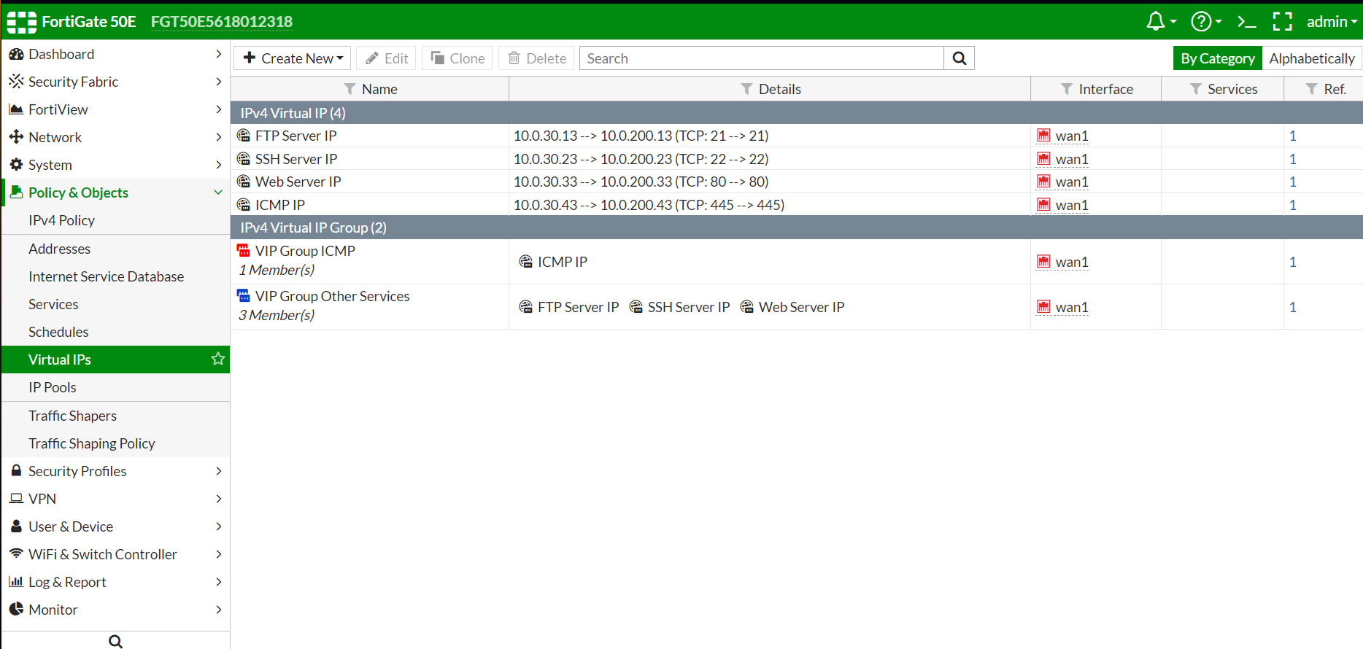
Solution screenshots (configuration pages): 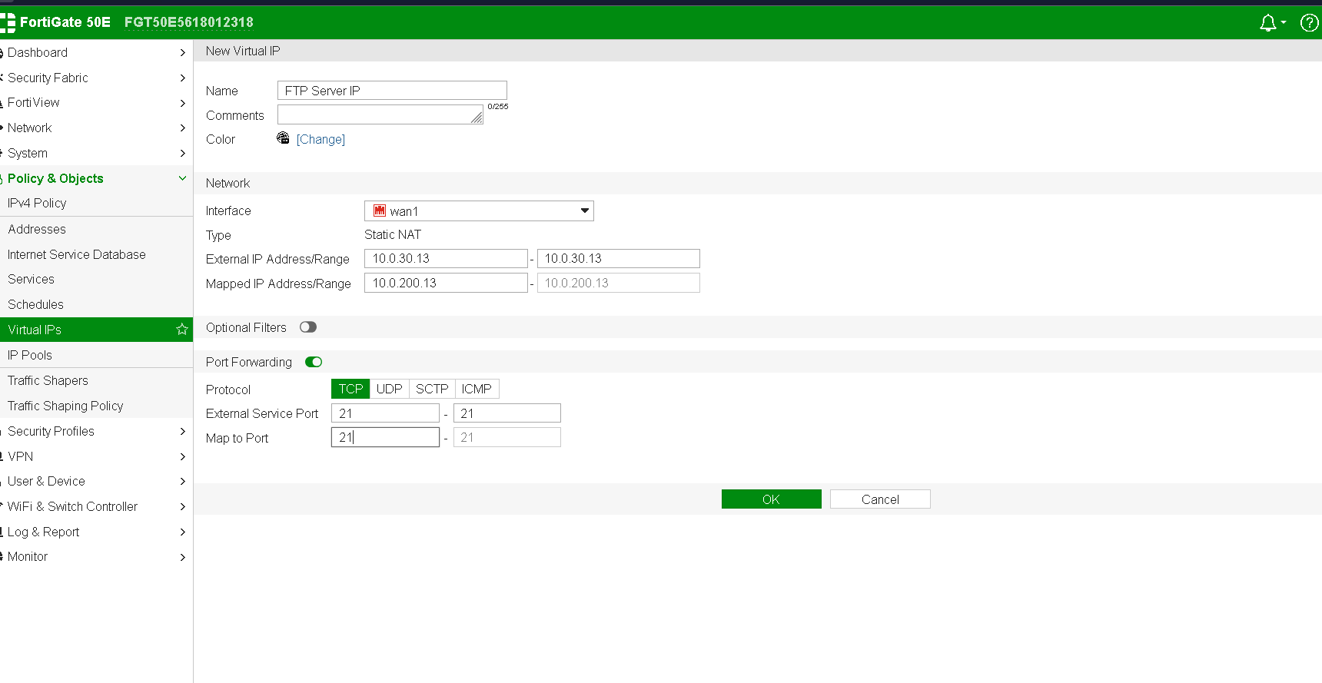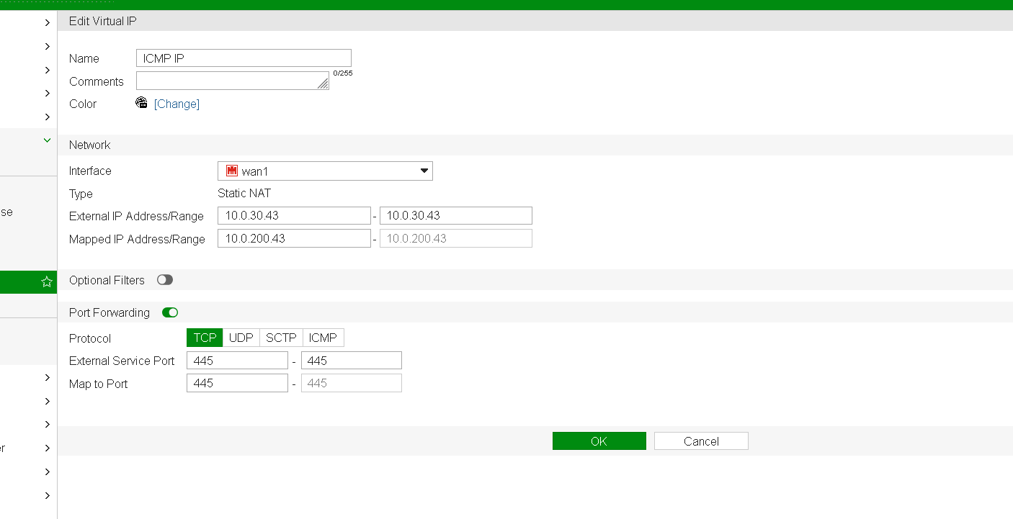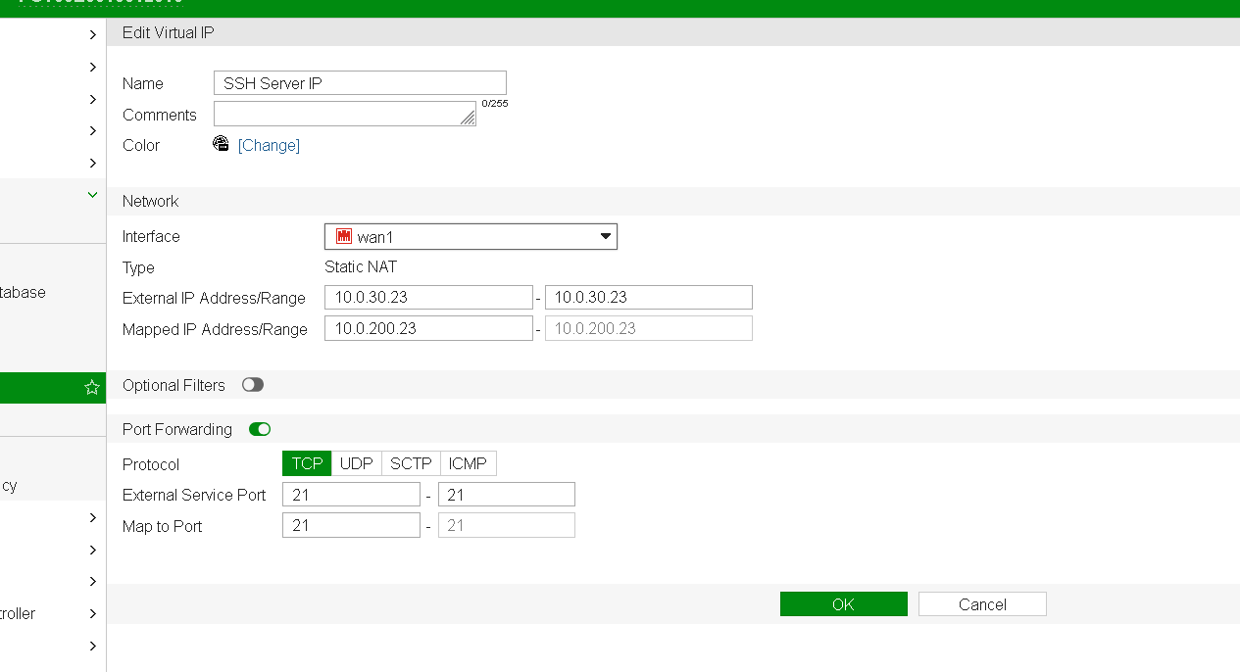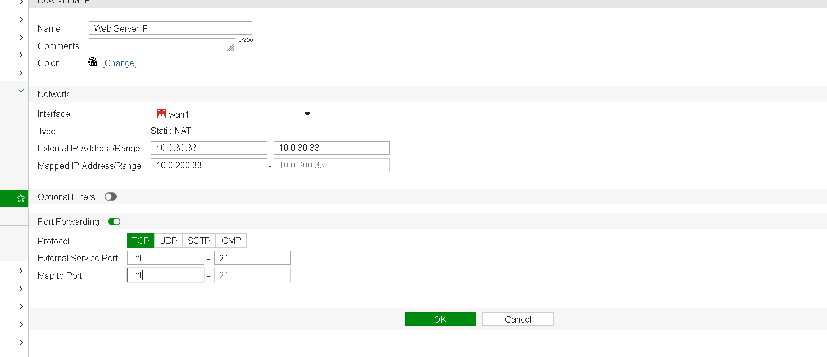
Results screenshot:

Task 15: Add VIP Group
In the virtual IPs page, click Create New and this time select VIP group.
- Add one VIP group for ICMP.
- Add one VIP group for all other services.
CLI to accomplish this task:
config firewall vipgrp
edit “VIP-Group-ICMP”
set member “VIP-ICMP”
https://docs.fortinet.com/document/fortigate/7.2.3/cli-reference/303620/config-firewall-vipgrp
config firewall policy
edit 12
set name "ICMP IP"
set srcintf "wan1"
set dstintf "lan"
set srcaddr "all"
set dstaddr "wan1"
set action accept
set schedule "always"
set service "ALL"
set nat enable
https://docs.fortinet.com/document/fortigate/7.2.3/cli-reference/323620/config-firewall-policy

Solution screenshots (configuration pages):
Results screenshot: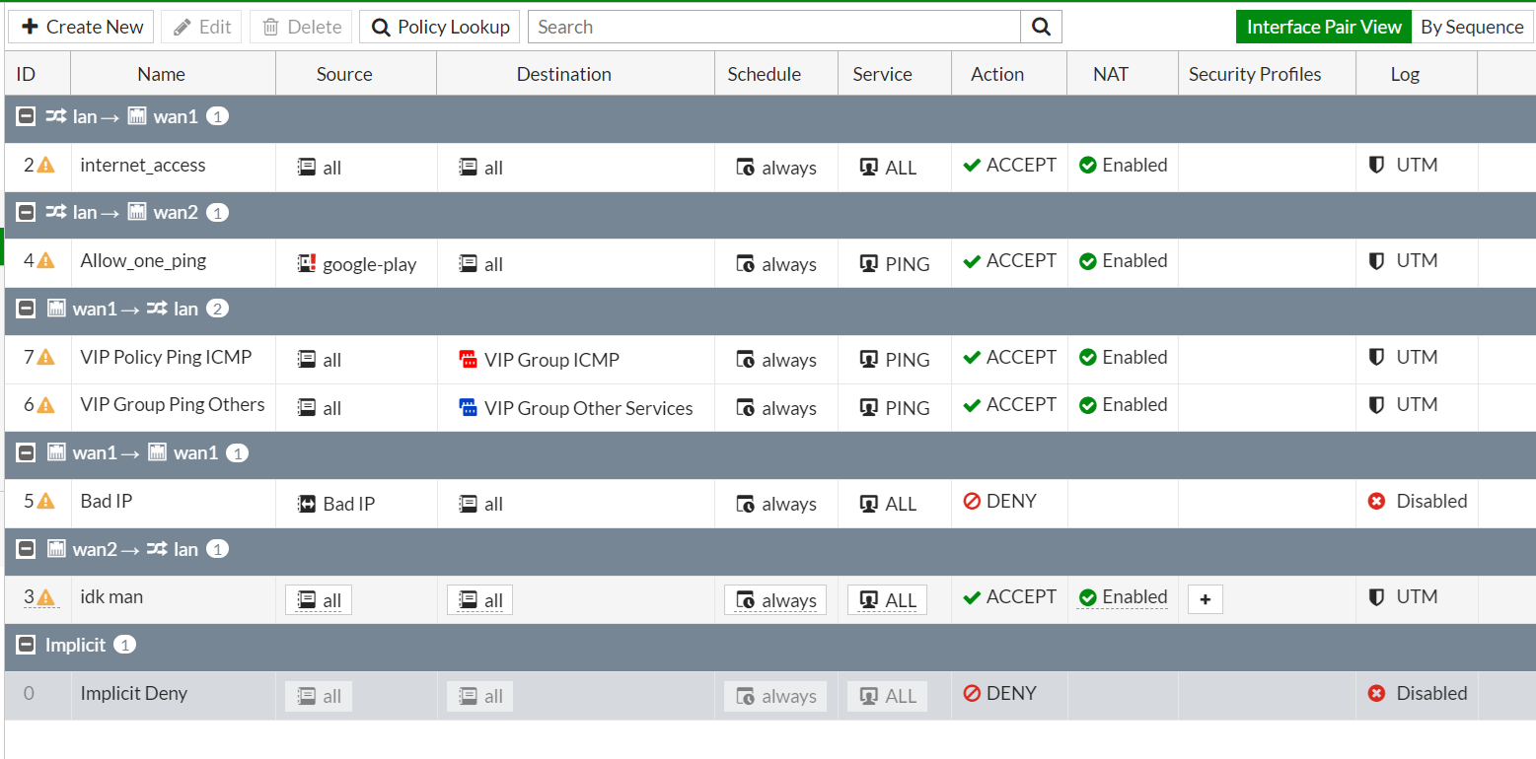

Task 16: Add VIP for Ping
Figure out, based on what you learned so far, how to add a policy rule to allow your VIP groups system to ping from within your firewall out to the instructor provided gateway. Note, you add the VIP group in a similar fashion to your individual server/service IPv4 policies.
CLI to accomplish this task: config firewall vip
edit "VIP Group Ping Others"
set extip 10.0.200.43
set extintf "wan1"
set mappedip 10.0.30.43

config firewall vipgrp
edit "VIP Group Ping Others"
set member "VIP-Ping"

config firewall policy
edit 13
set name "VIP Group Ping Others"
set srcintf "lan"
set dstintf "wan1"
set srcaddr "all"
set dstaddr "VIP Group Ping Others"
set action accept
set schedule "always"
set service "PING"
set nat enable
set logtraffic all
https://docs.fortinet.com/document/fortigate/7.2.3/cli-reference/323620/config-firewall-policy
https://docs.fortinet.com/document/fortigate/7.2.3/cli-reference/303620/config-firewall-vipgrp
https://docs.fortinet.com/document/fortigate/7.2.3/cli-reference/301620/config-firewall-vip

Provide your configuration file:
Solution screenshots (configuration pages):

Goal 3: Setup Web Server
Using the assigned Raspberry Pi, set up a web server.
Here is a general guide you can follow:
https://thepi.io/how-to-set-up-a-web-server-on-the-raspberry-pi/
Provide step by step screenshots:
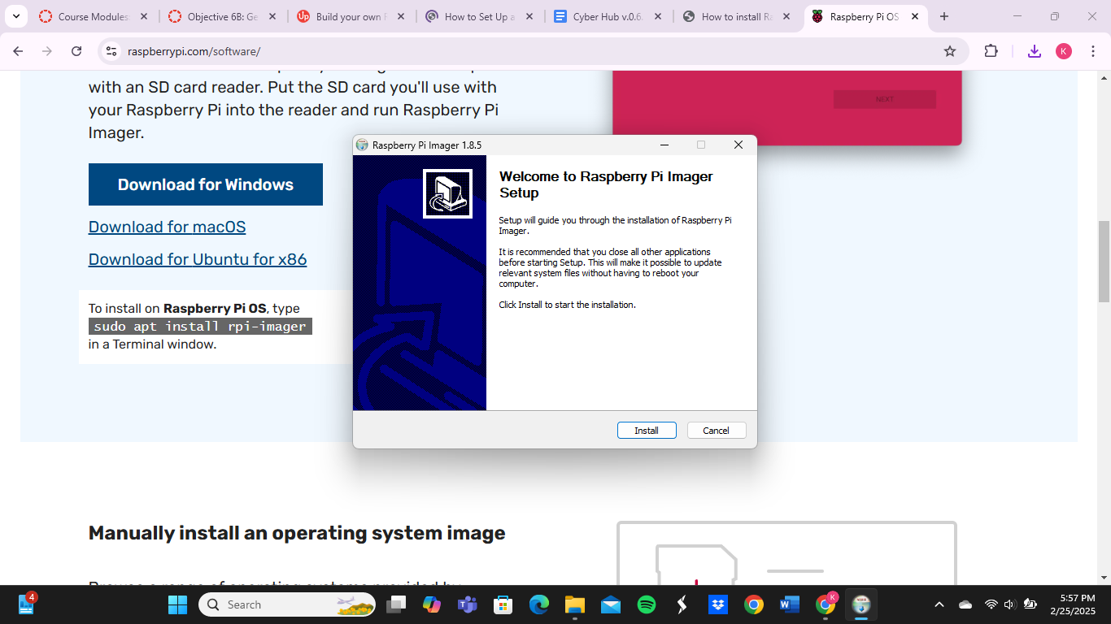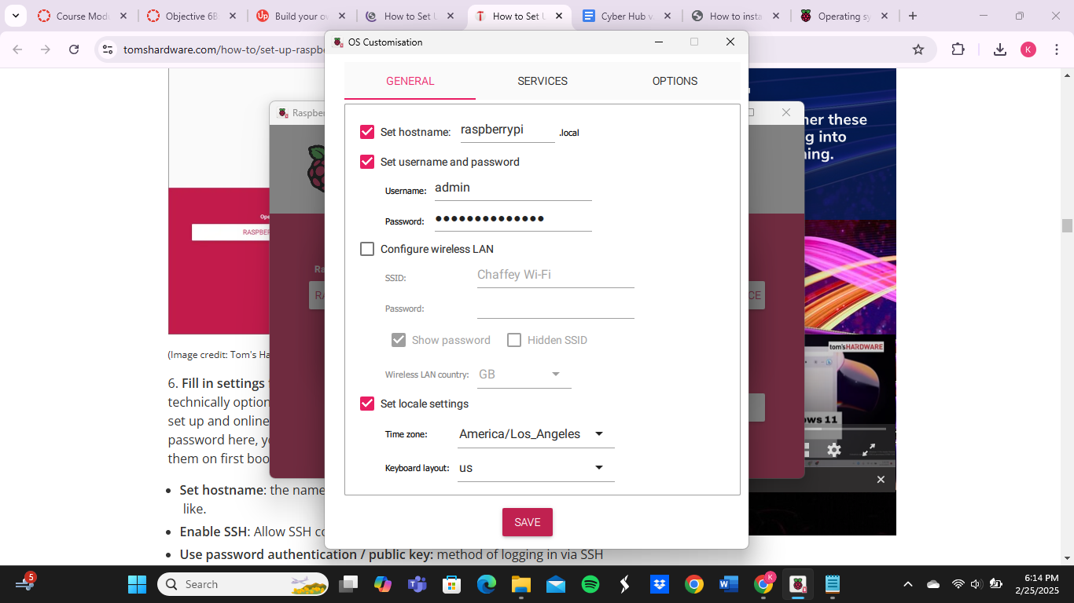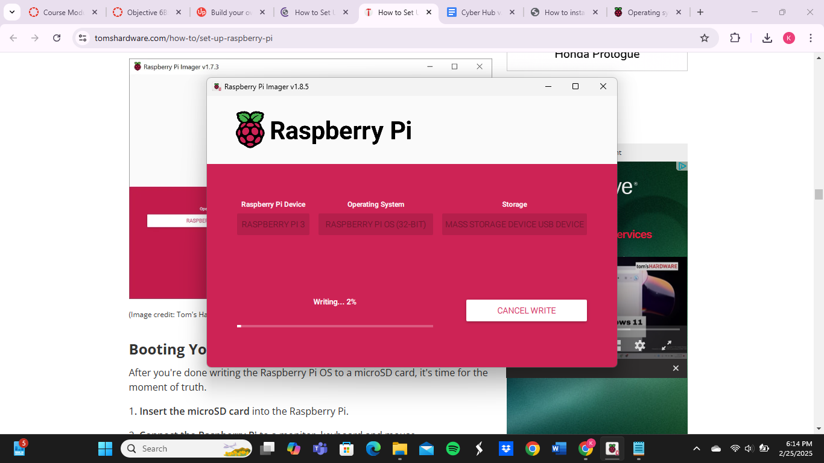
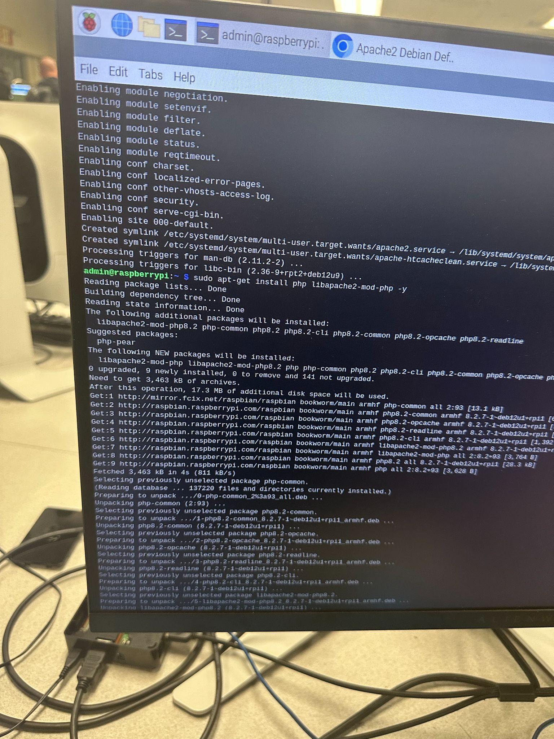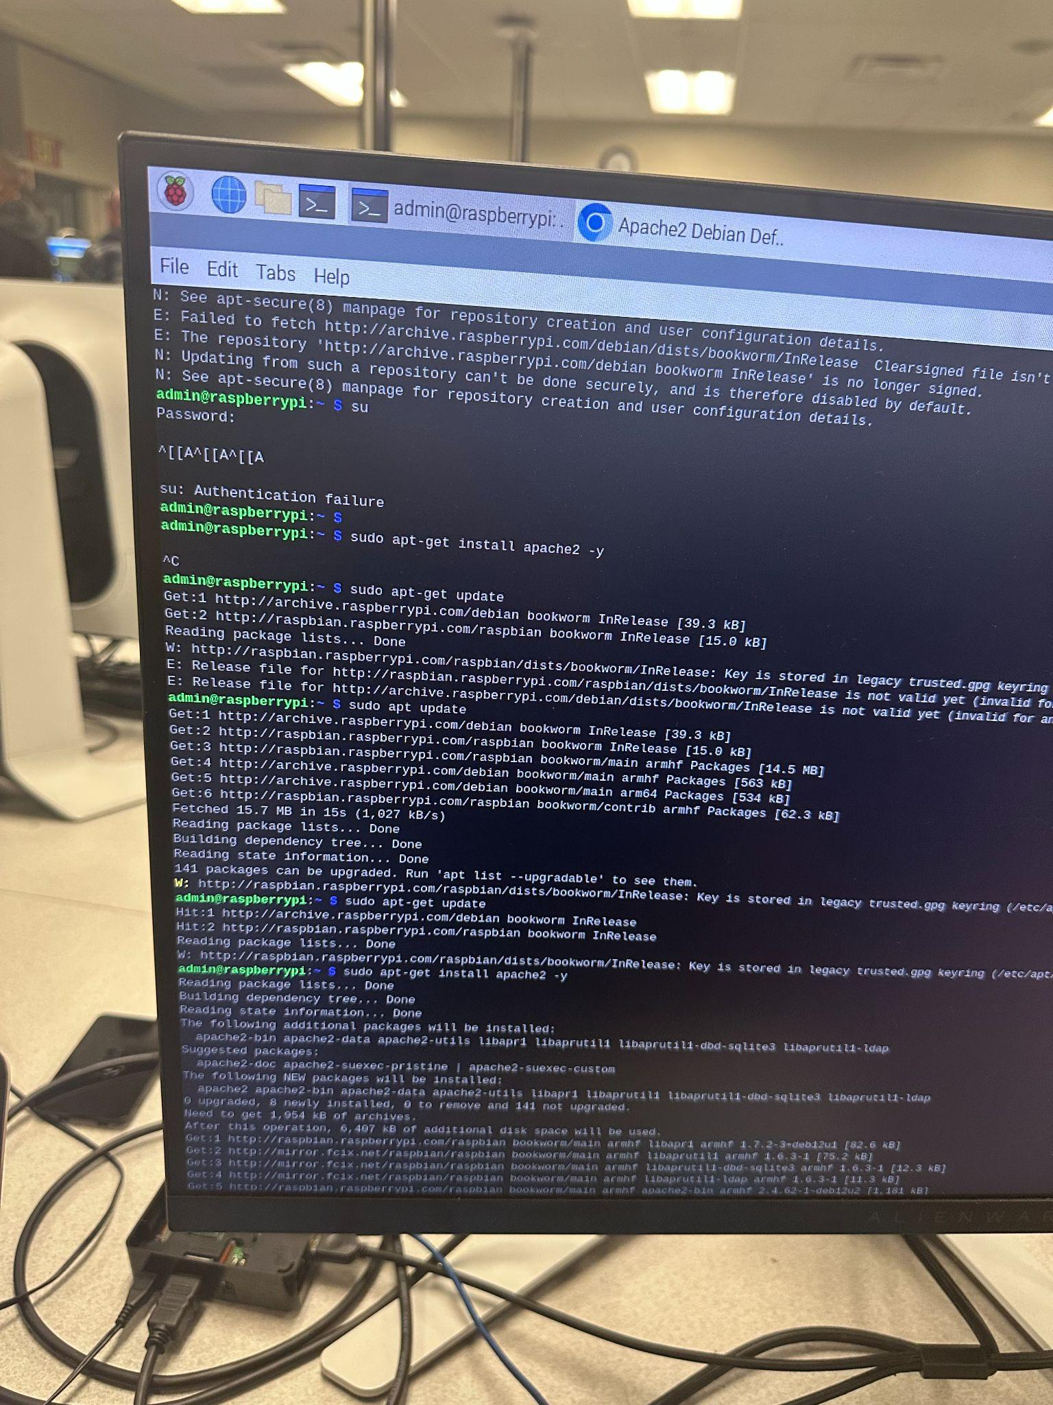
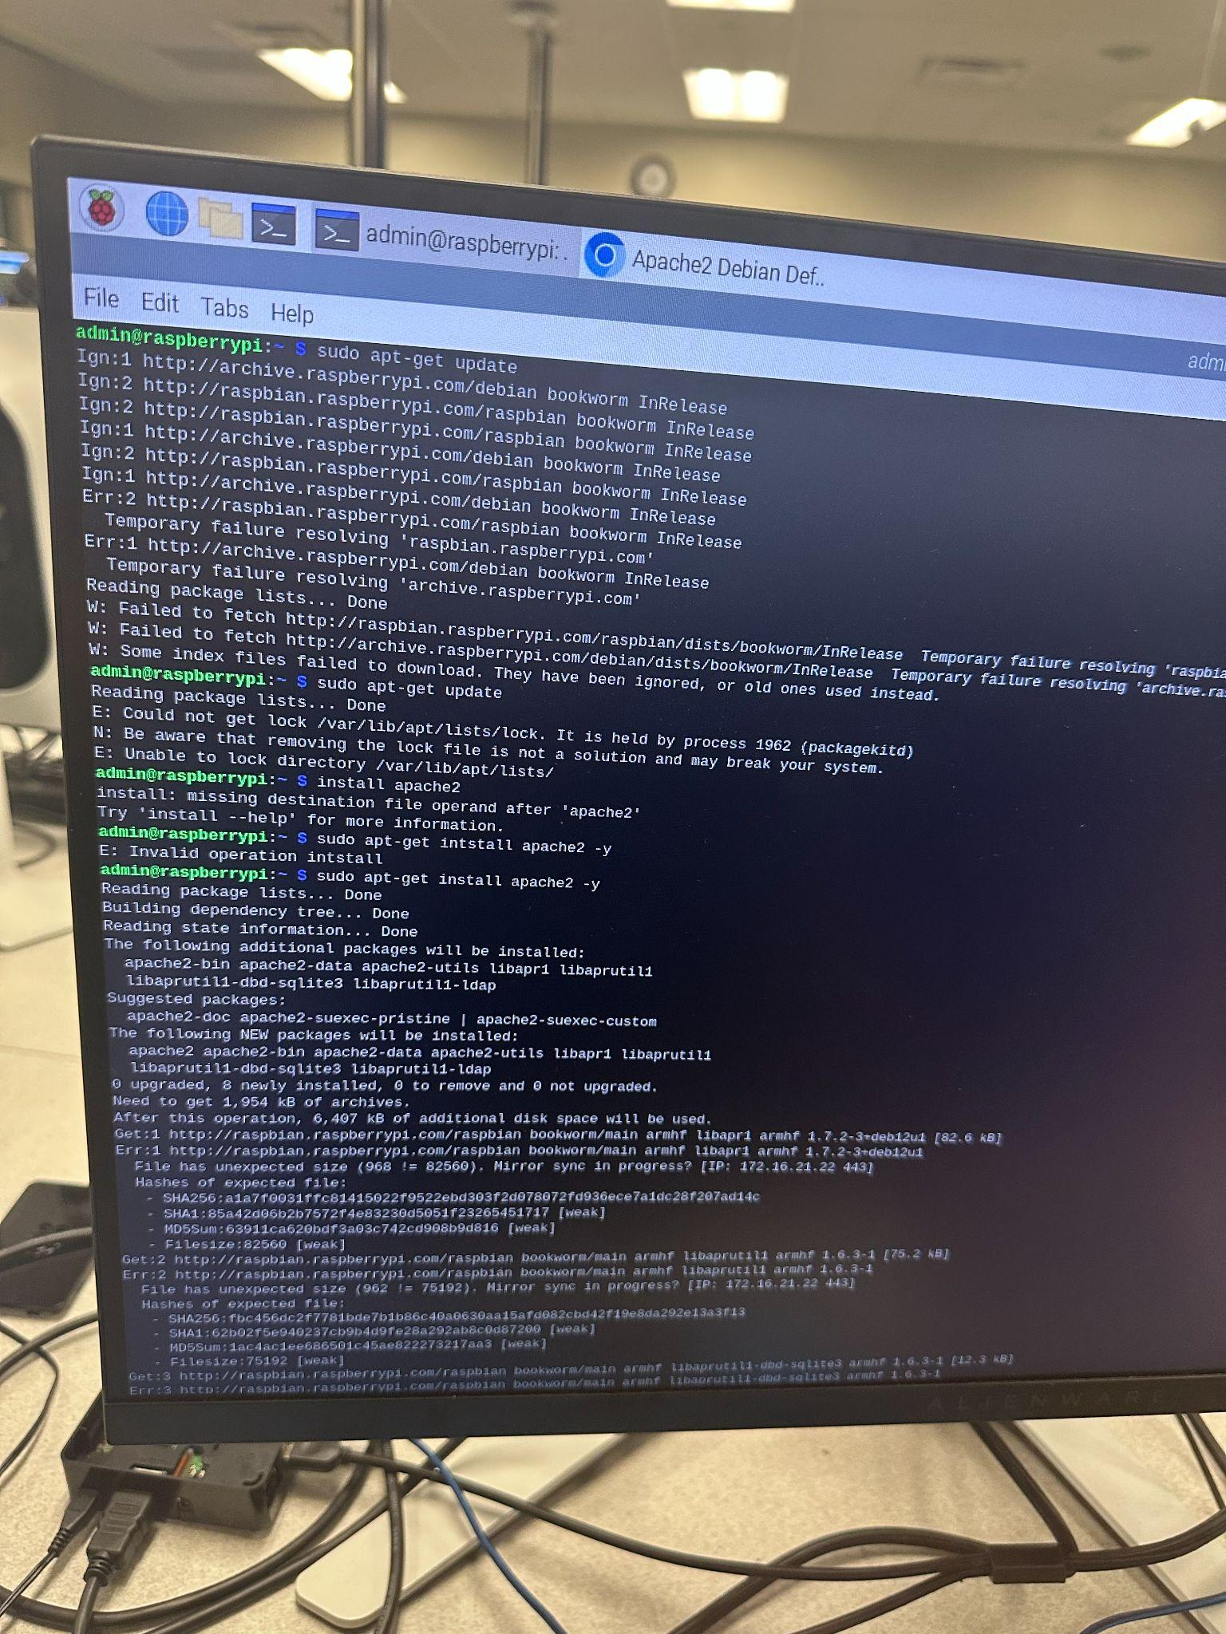
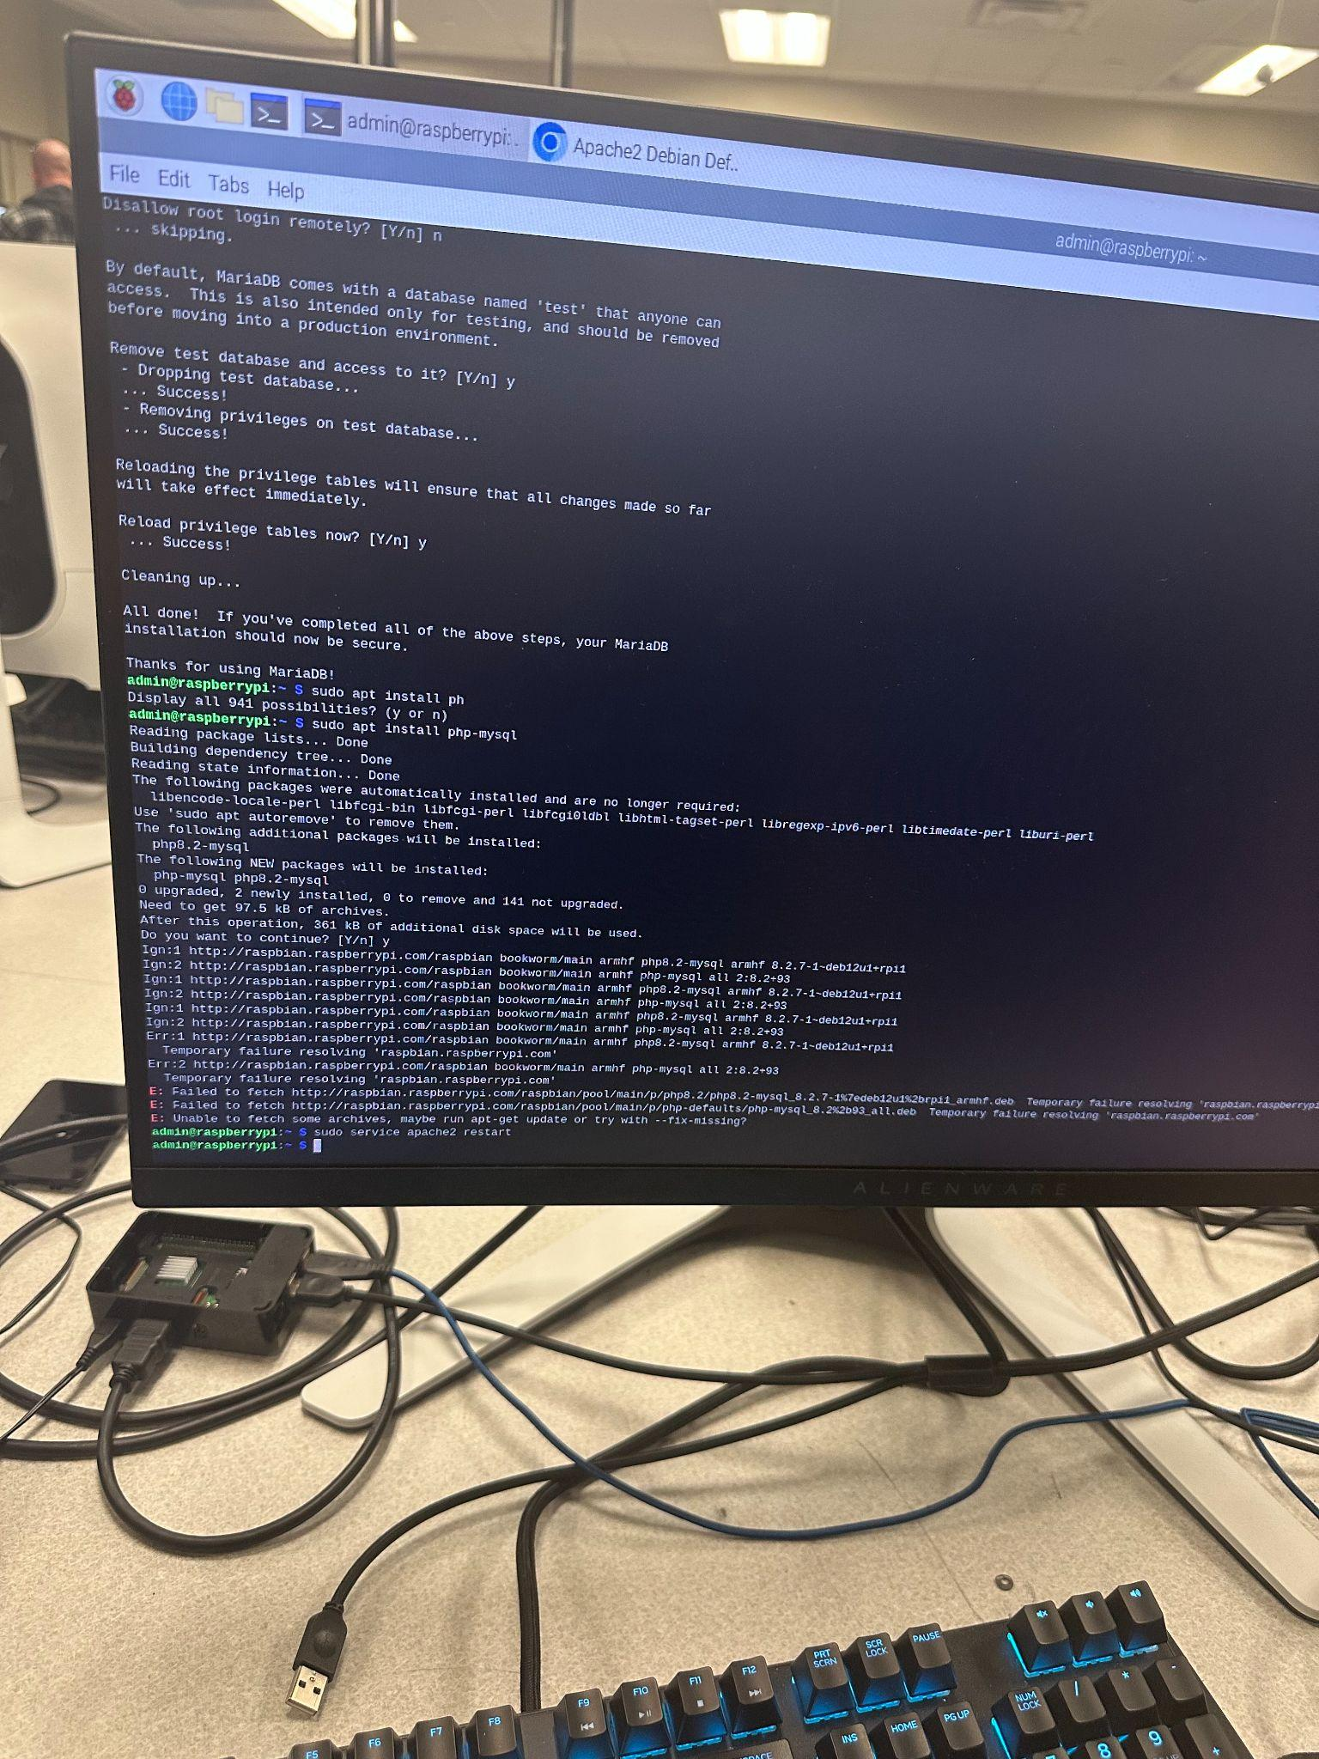
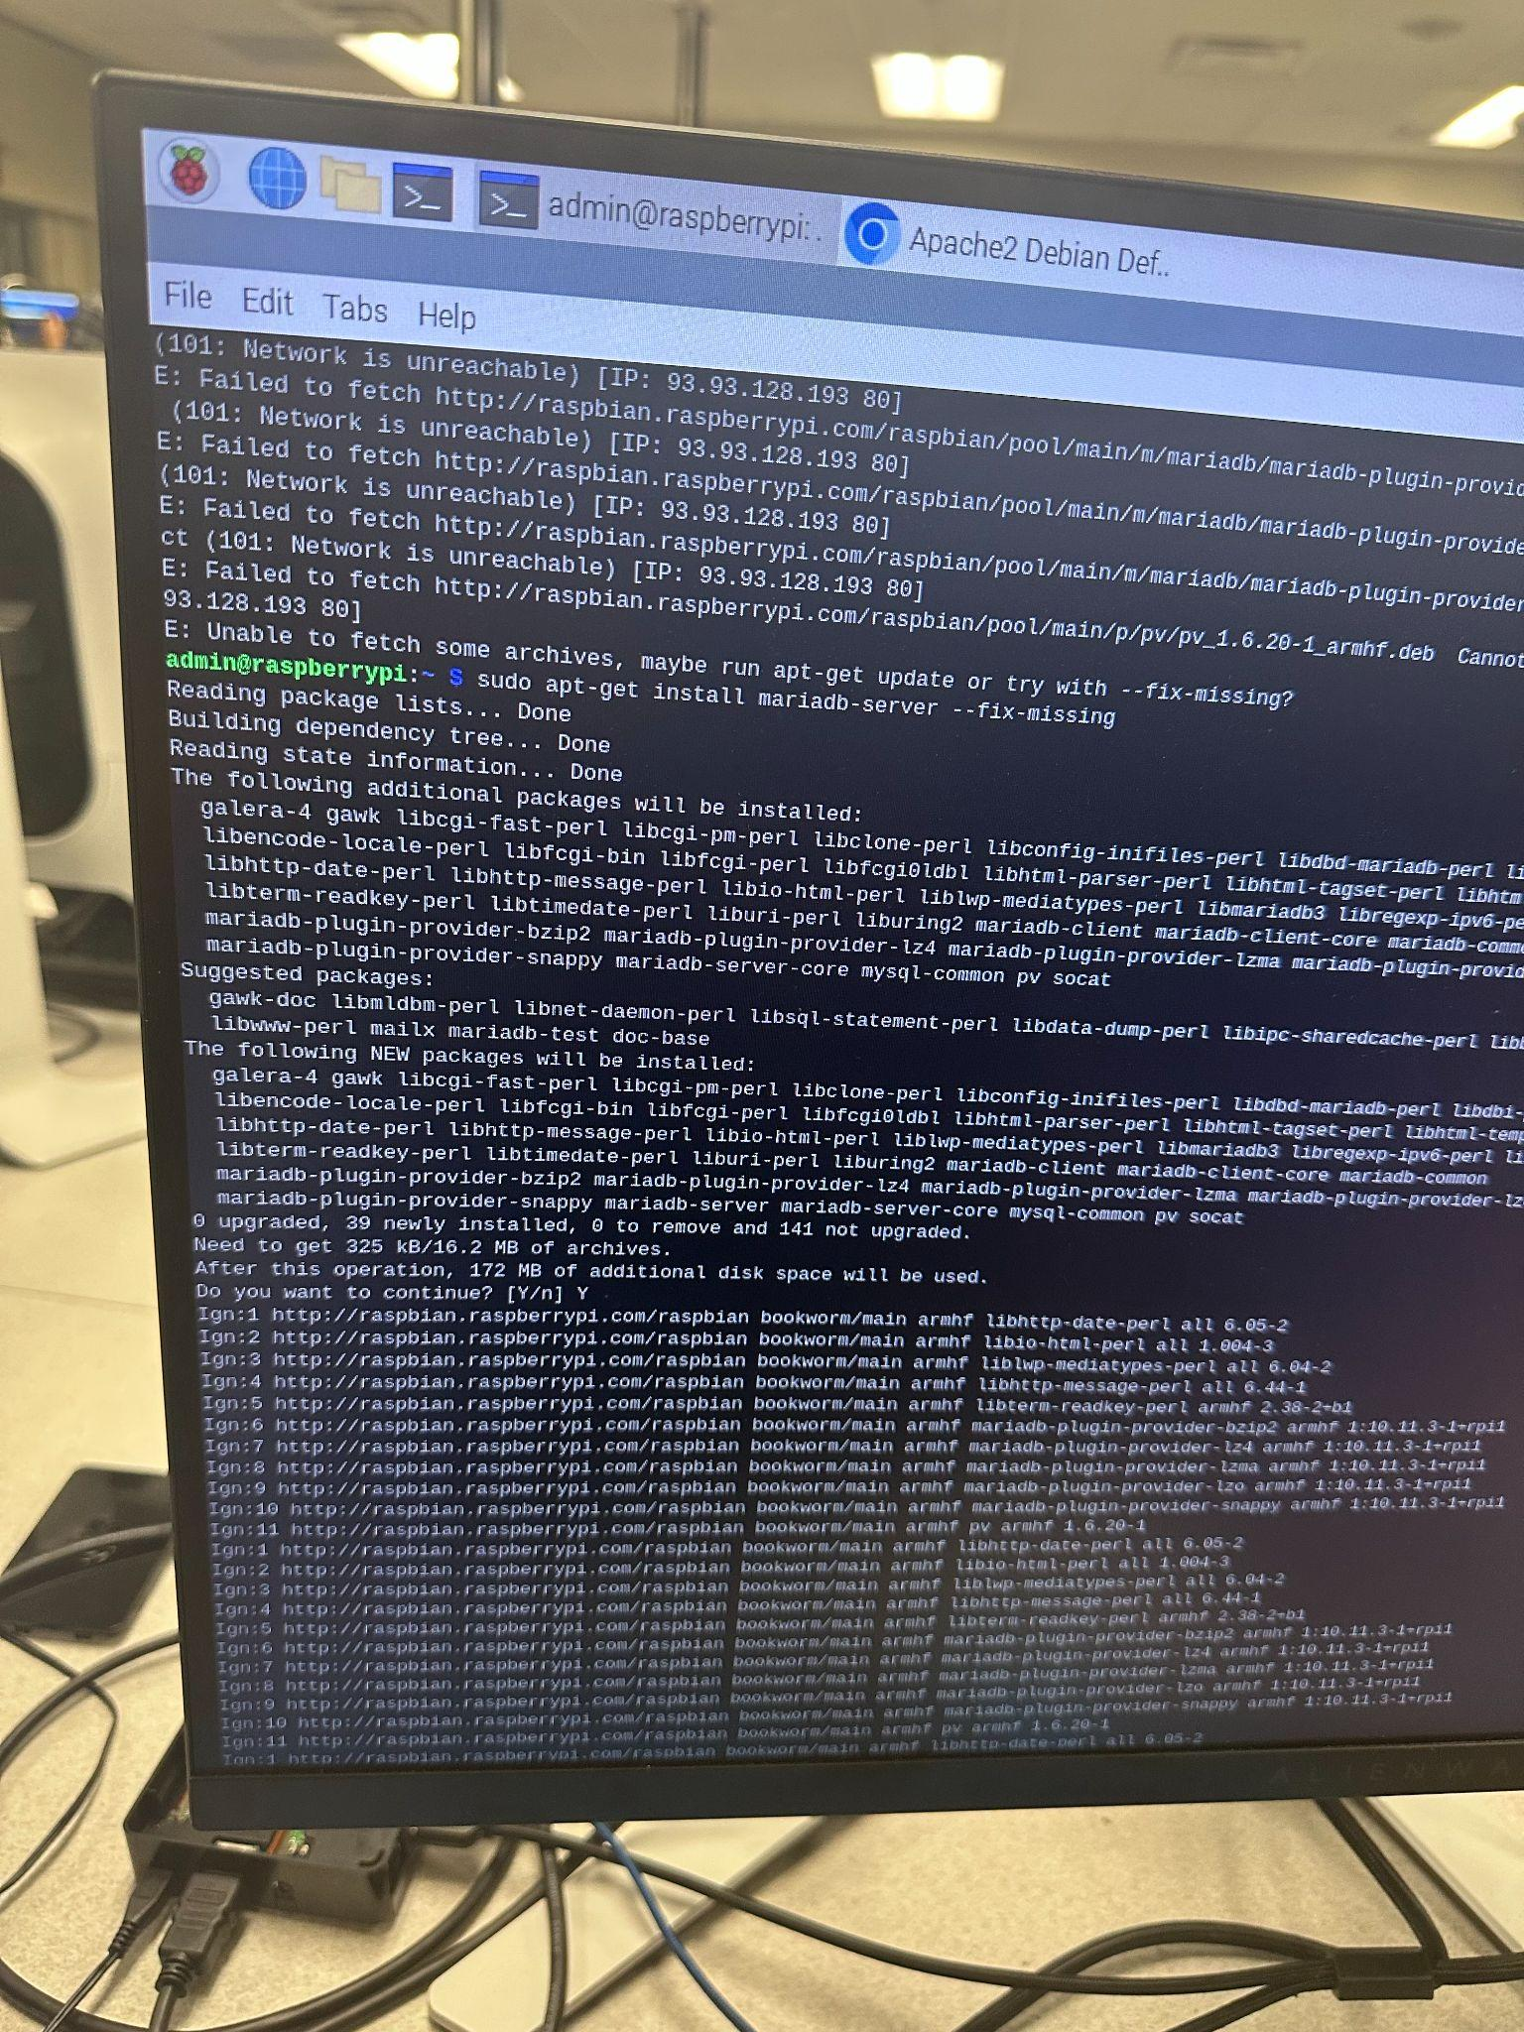
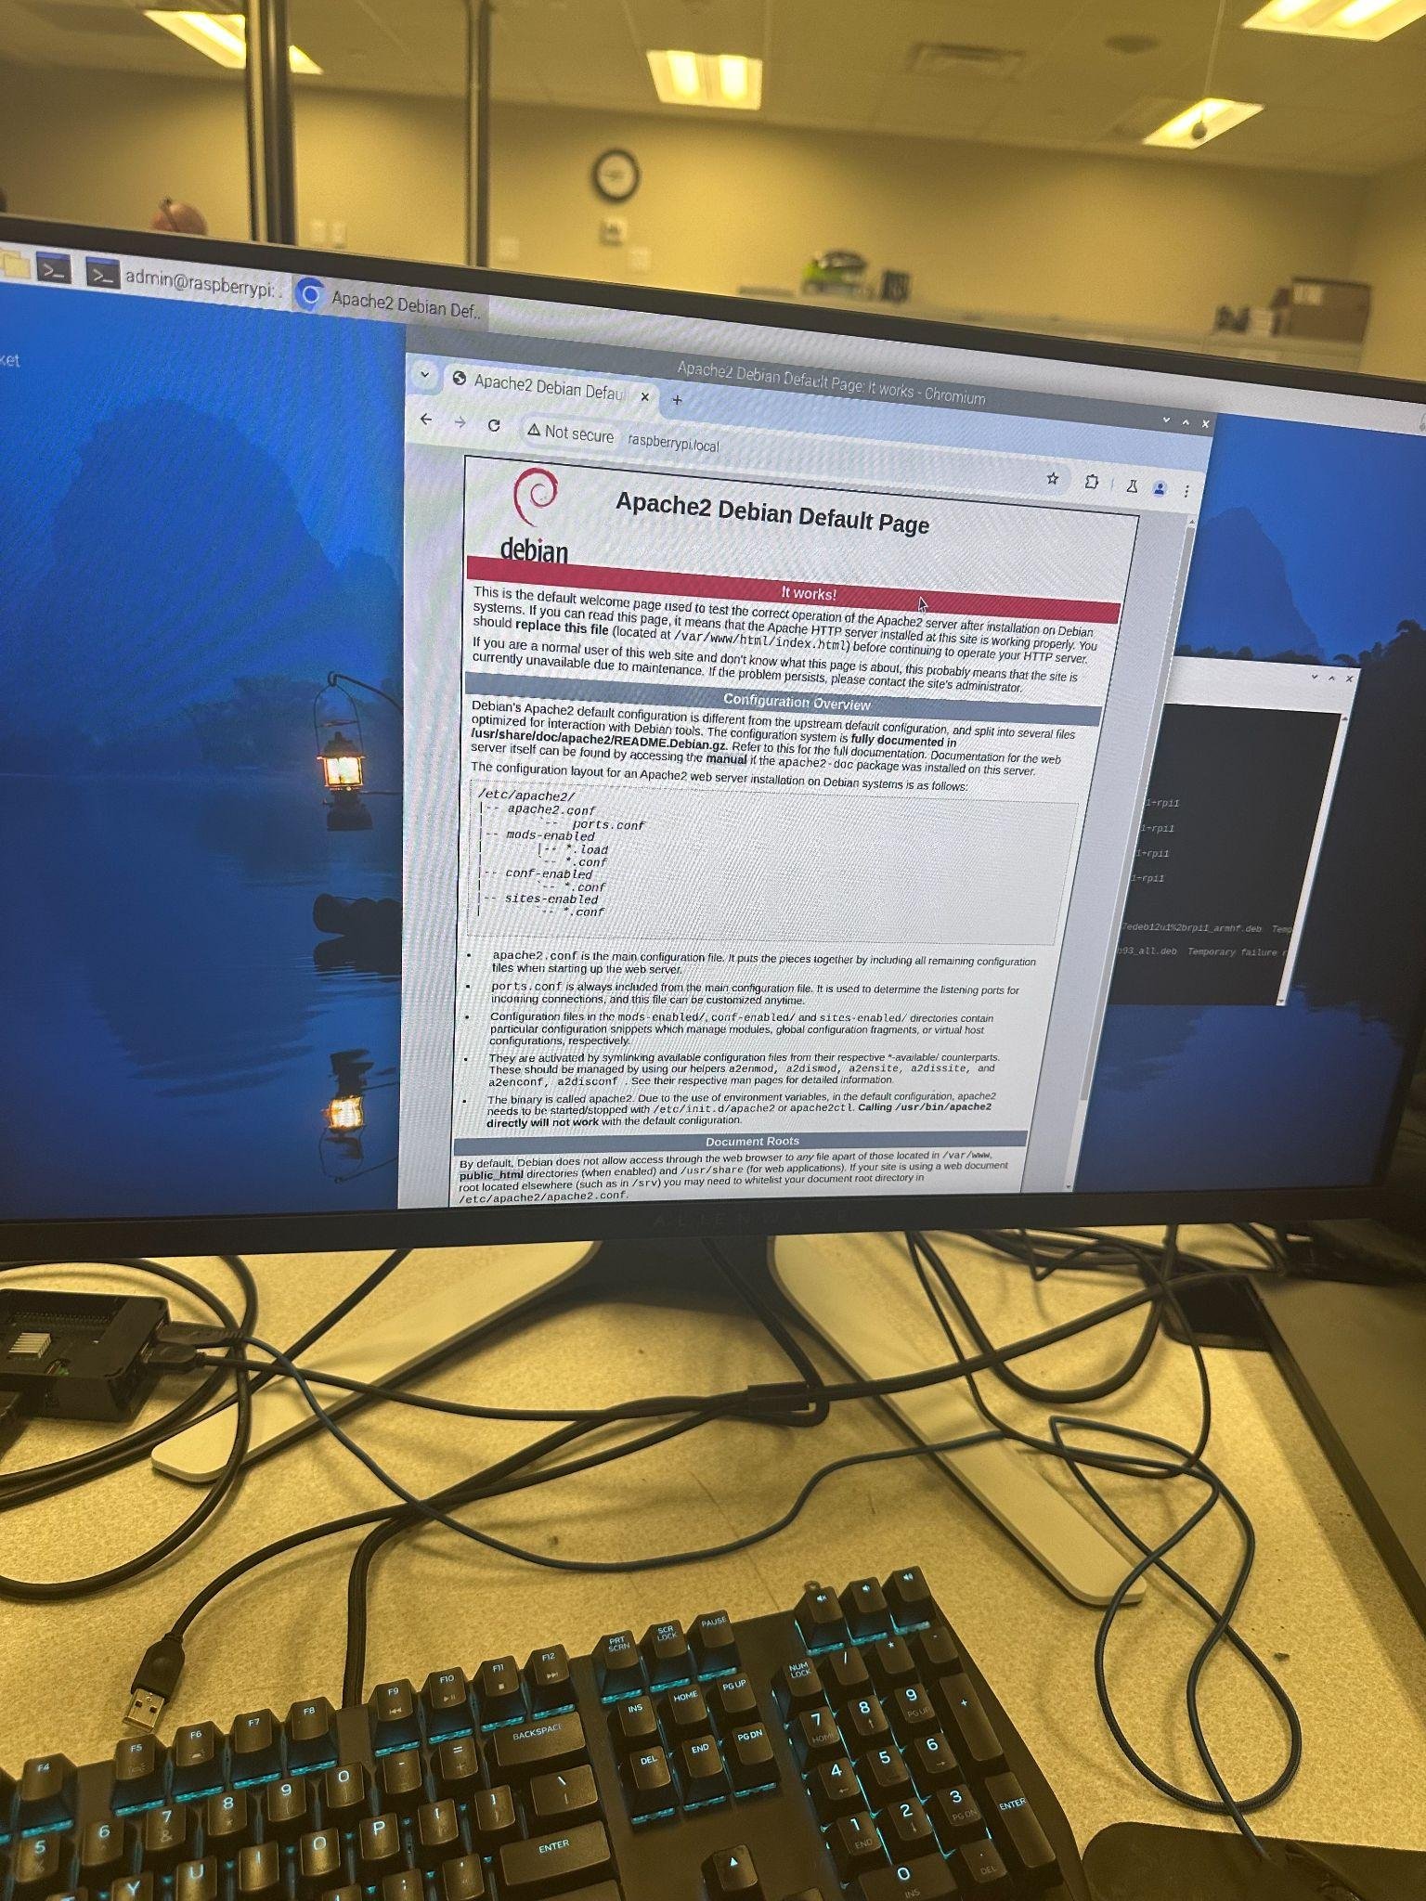
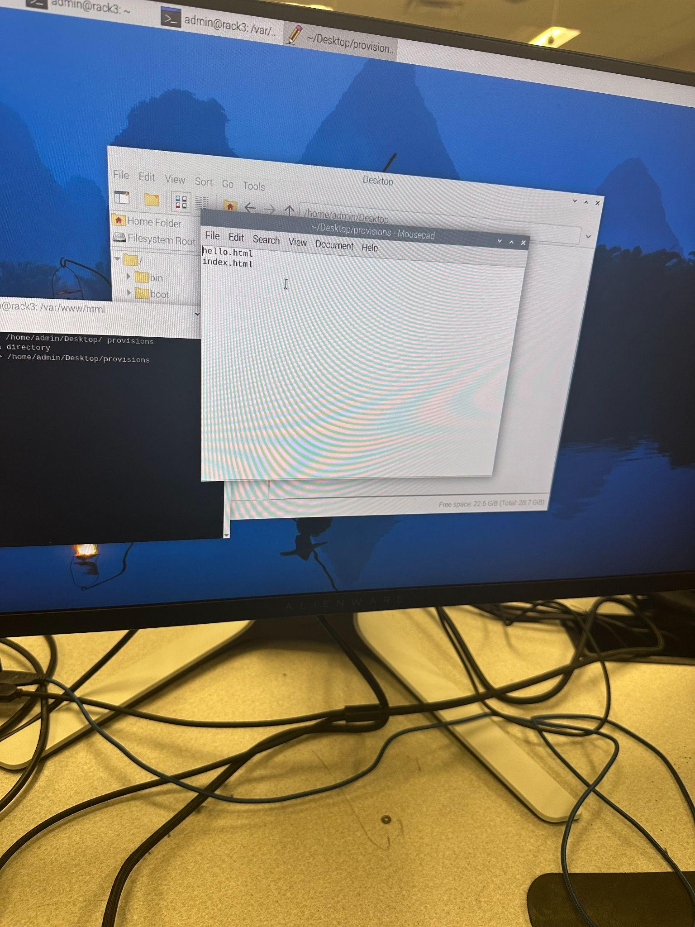

Goal 4: Setup Network Switch

Task 1: Connect to the Switch
Our switch documentation can be found here: https://www.cisco.com/c/en/us/td/docs/switches/lan/csbms/CBS_250_350/Administration-Guide/cbs-350.pdf
We will be configuring the switch using the web interface.
- Confirm all three left-hand status lights are green.
- Connect to any network port on the switch from your laptop.
- We assigned the switch a static IP in Goal 1 Task 1, noted in your Rack Documentation.
- Open a browser and navigate to your Switch IP address.

Task 2: Access the Web Interface
Login with the credentials we assigned in Goal 1 Task 1.
Change the interface from “Basic” to “Advanced” to see all the available options.
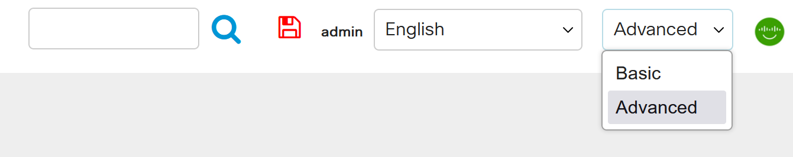

Task 3: Save and Back Up Configuration
Whenever we make a configuration change to the switch, we save those changes by clicking the save icon at the top of the screen:
As with the firewall, we should save the configuration file after ever major change:
- Click on Administration, then click File Operations.
- Select Backup File, Running Configuration, and HTTP/HTTPS:
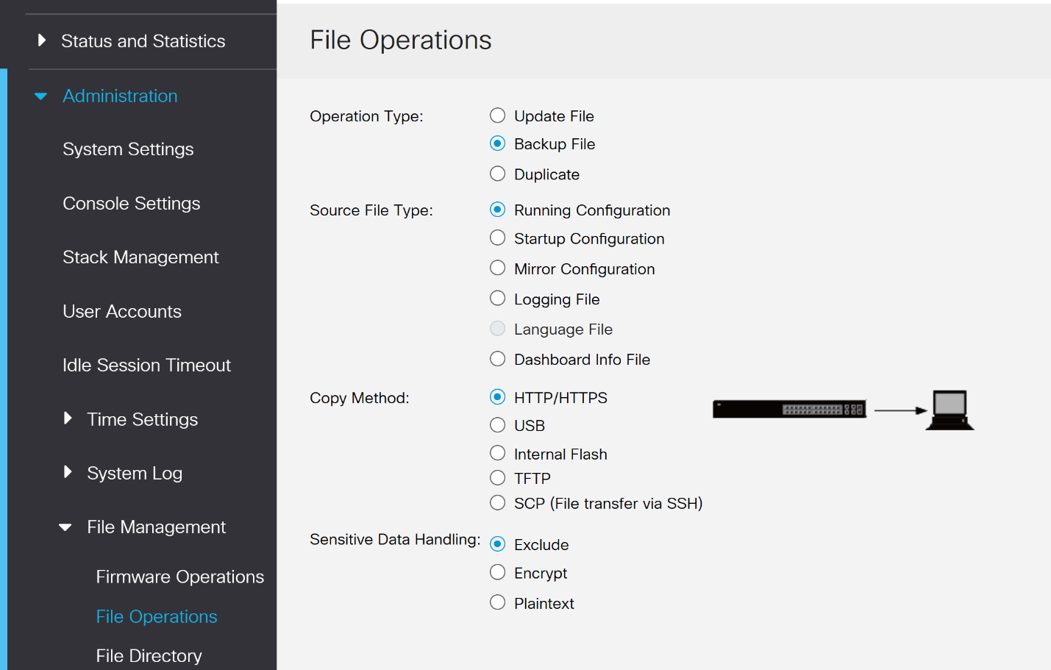
- Click Apply.
Repeat these steps before and after any change to the system.
CLI to accomplish this task:
write memory
copy running-config startup-config
https://www.cisco.com/c/en/us/td/docs/switches/lan/csbms/CBS_250_350/CLI/cbs-350-cli-.pdf

Task 4: Services
TCP/UDP services enable communication for network management and specific protocols. We will enable certain services to allow secure performance of network functions and management tasks.
Go to the interface home screen and click Getting Started, under initial setup click Change Management Applications and Services and enable all services except SNMP:
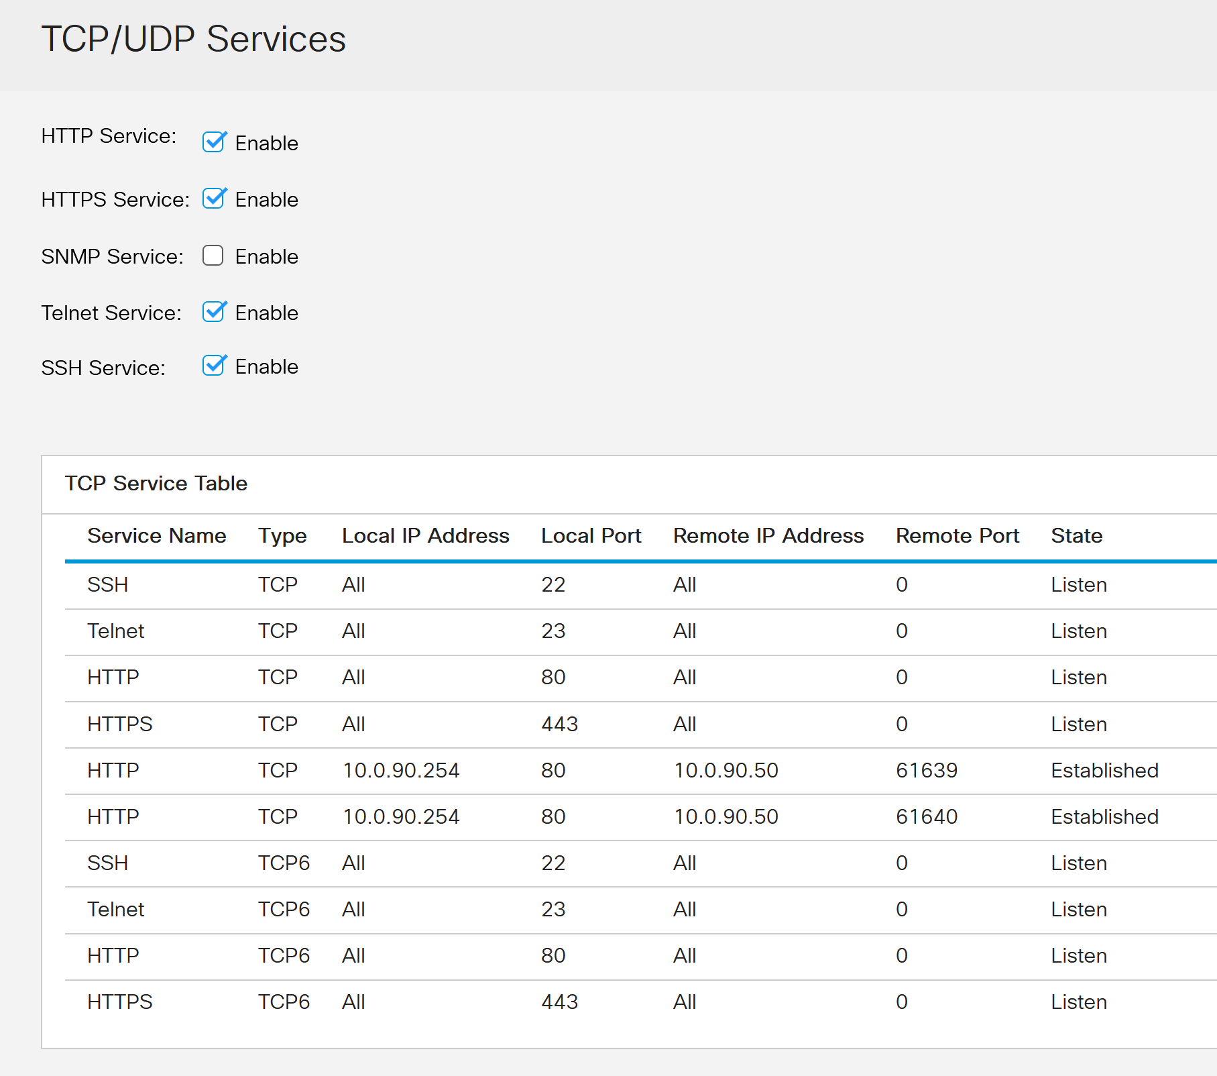
Click Apply and save your configuration.
CLI to accomplish this task:
enable
configure terminal
ip ssh version 2
ip http server
ip http secure-server
no snmp-server
https://www.cisco.com/c/en/us/td/docs/switches/lan/csbms/CBS_250_350/CLI/cbs-350-cli-.pdf

Task 5: VLAN Setup
A Virtual Local Area Network (VLAN) is a logical subnetwork that groups a collection of devices from different physical LANs. VLANs are helpful in improving the performance of busy networks by grouping client devices that communicate frequently with each other.
We assigned the default VLAN 1 a static IP in Goal 1 Task 1. You can see this under the IPv4 Interfaces:
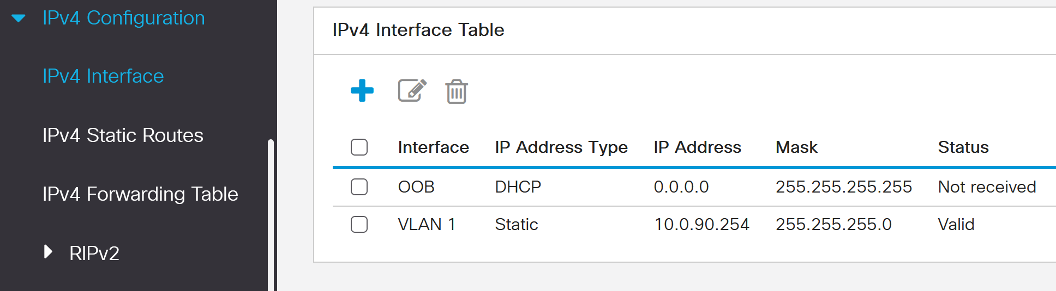
Note if you see VLAN 1 DHCP go ahead and delete it.
We will set up the following VLANs using your group's network schema. Rack 9 is used as an example:
ID | Segment | Subnet | Gateway | Switch Ports | Description
1 | 10.0.30.0 | 255.255.255.0 | 10.0.30.254 | XG1 | Switch Management
31 | 10.0.31.0 | 255.255.255.0 | 10.0.31.254 | XG2-8 | Data Network
32 | 10.0.32.0 | 255.255.255.0 | 10.0.32.254 | XG9-10 | Management Network
33 | 10.0.33.0 | 255.255.255.0 | 10.0.33.254 | N/A | NFS/CIFS Network
34 | 10.0.34.0 | 255.255.255.0 | 10.0.34.254 | N/A | iSCSI Network
35 | 10.0.35.0 | 255.255.255.0 | 10.0.35.254 | N/A | vMotion Network
36 | 10.0.36.0 | 255.255.255.0 | 10.0.36.254 | XG11 | FT Network
37 | 10.0.37.0 | 255.255.255.0 | 10.0.37.254 | XG12 | DMZ Network
420 | 192.168.1.0 | 255.255.255.0 | 192.168.1.254 | OOB | OOB Management

Go to VLAN Management and then VLAN Settings, then click the plus sign:
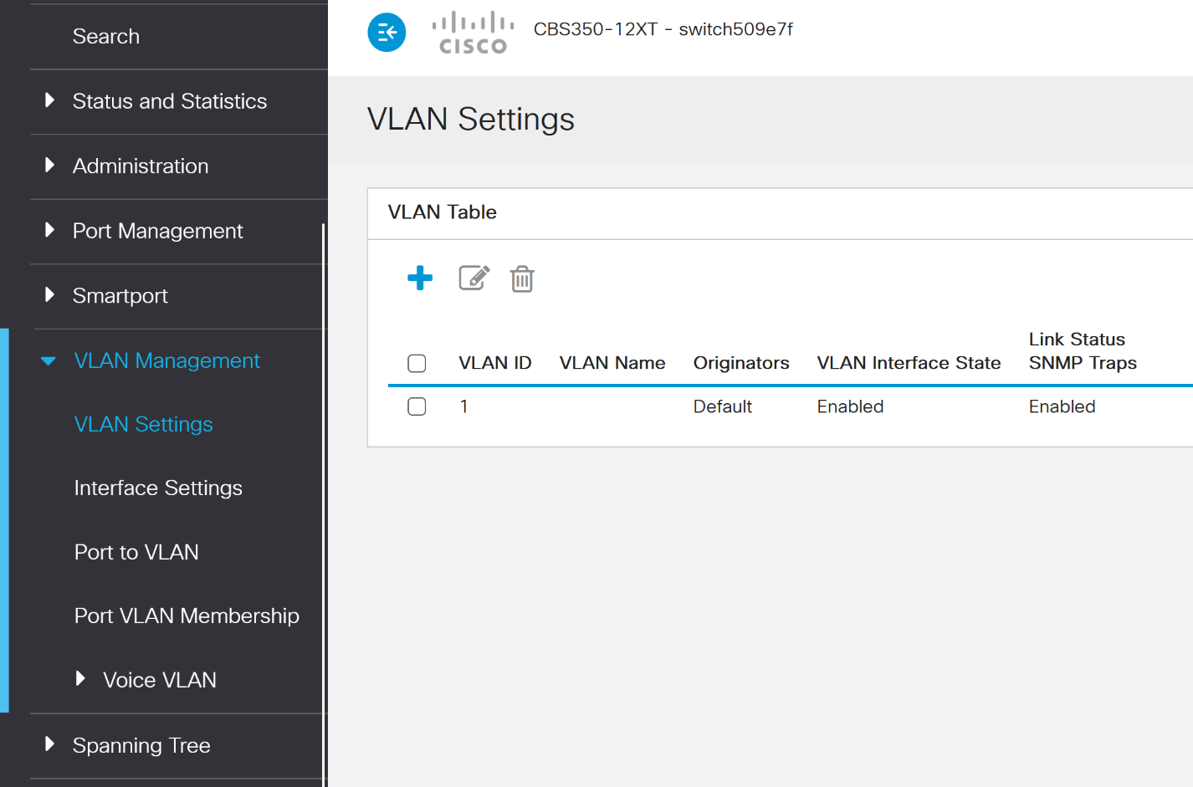
CLI to accomplish this task:
enable
configure terminal
vlan 31
name Data_Network
vlan 32
name Management_Network
vlan 33
name NFS_CIFS_Network
vlan 34
name iSCSI_Network
vlan 36
name FT_Network
vlan 37
name DMZ_Network
vlan 420
name OOB_Management
interface range gigabitethernet1/0/1 - 4
switchport mode access
switchport access vlan 31
interface range gigabitethernet1/0/5 - 8
switchport mode access
switchport access vlan 32
interface range gigabitethernet1/0/9 - 12
switchport mode access
switchport access vlan 33
interface range gigabitethernet1/0/13 - 16
switchport mode access
switchport access vlan 34
interface range gigabitethernet1/0/17 - 20
switchport mode access
switchport access vlan 35
interface range gigabitethernet1/0/21 - 24
switchport mode access
switchport access vlan 36
interface range gigabitethernet1/0/25 - 28
switchport mode access
switchport access vlan 37
interface range gigabitethernet1/0/29 - 32
switchport mode access
switchport access vlan 420
write memory

https://www.cisco.com/c/en/us/td/docs/switches/lan/csbms/CBS_250_350/CLI/cbs-350-cli-.pdf

Create the Data Network VLAN following your Rack’s network schema: 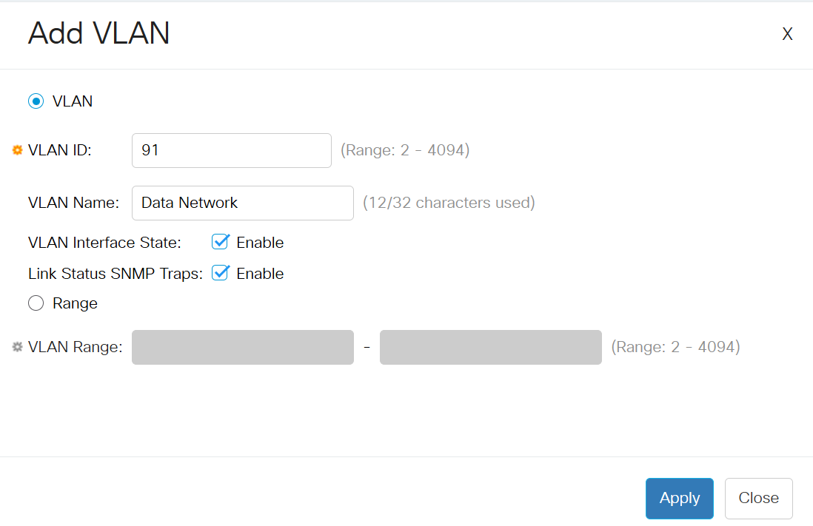
Repeat this step for each VLAN as decided on the above table.
Save your configuration.
Next, we will assign specific interfaces to each VLAN:
Under VLAN Management, click on Interface Settings.
Access mode assigns a switch port to a single VLAN, allowing only traffic from that VLAN to pass through. For our network we need to use Trunk mode for ports XG2 through XG12, which allows multiple VLANs to pass through a single network link between switches:
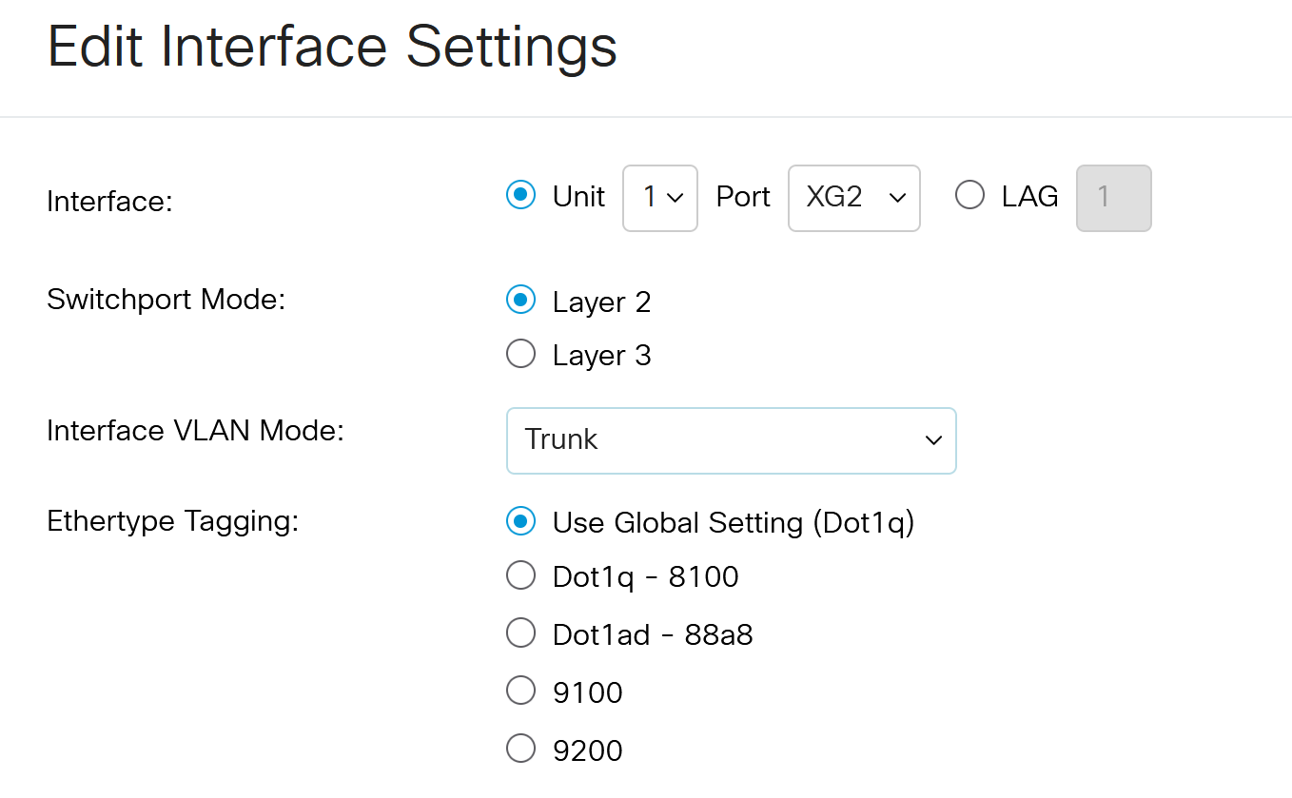
Now copy the XG2 settings to ports 3 through 12 using the copy settings icon:
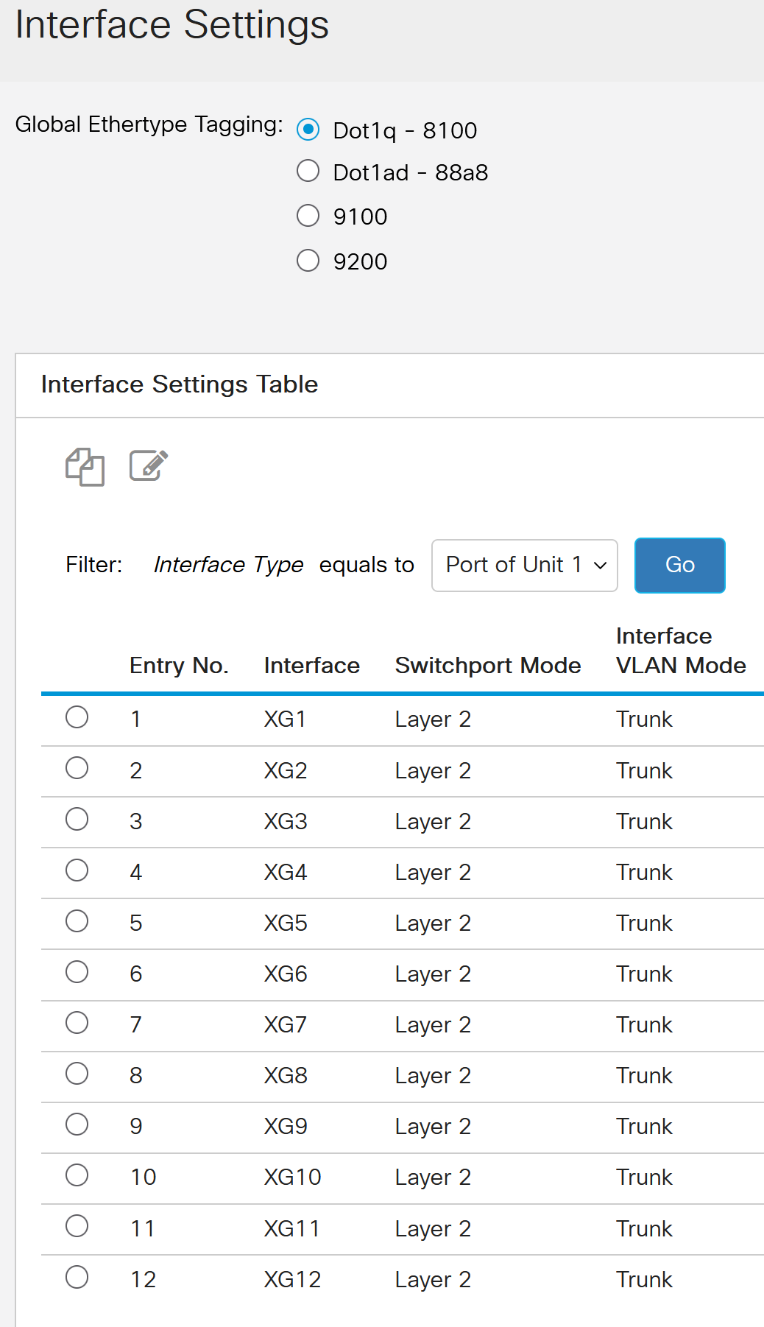
Save your configuration.
Now that we have created our VLANs, we need to set up a static IP for our Data Network. Return to IPv4 Interfaces and assign the IP based on your network schema:
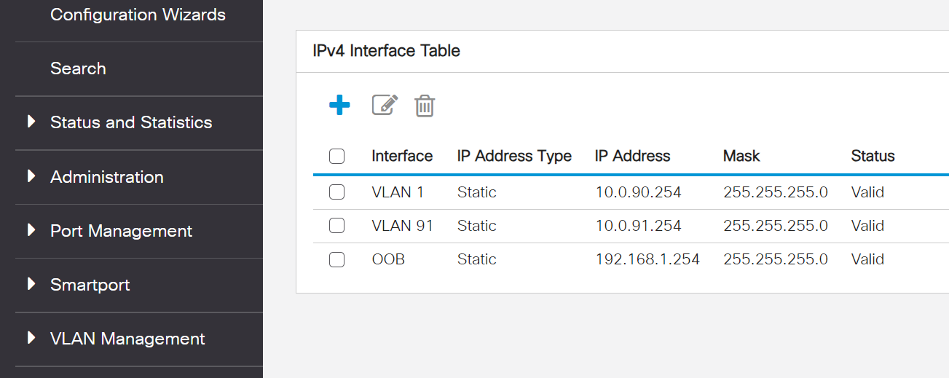
Make sure you click Apply at the top right of the screen, then save your configuration.
Repeat the process for your Management Network VLAN.

Task 6: DHCP
You should remember from your previous networking classes DHCP automatically assigns IP addresses to devices on a network using predefined DHCP pools, which are ranges of IP addresses reserved for dynamic allocation to clients.
First turn on DHCP by checking the box under IPv4 Interface 🡪 DHCP Server 🡪 Properties.
Next go to DHCP Server 🡪 Network Pools and click the plus sign, and add a pool for your Data Network:
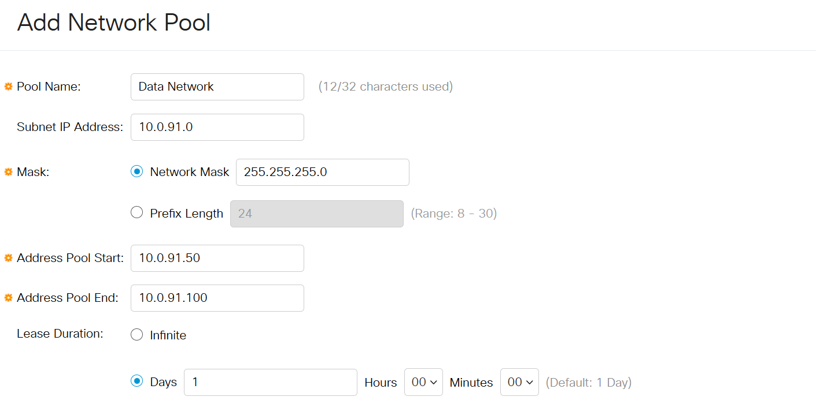
Repeat this process for your Management Network.
For DHCP to work properly we need to assign a native VLAN to specific ports under Port VLAN Management:
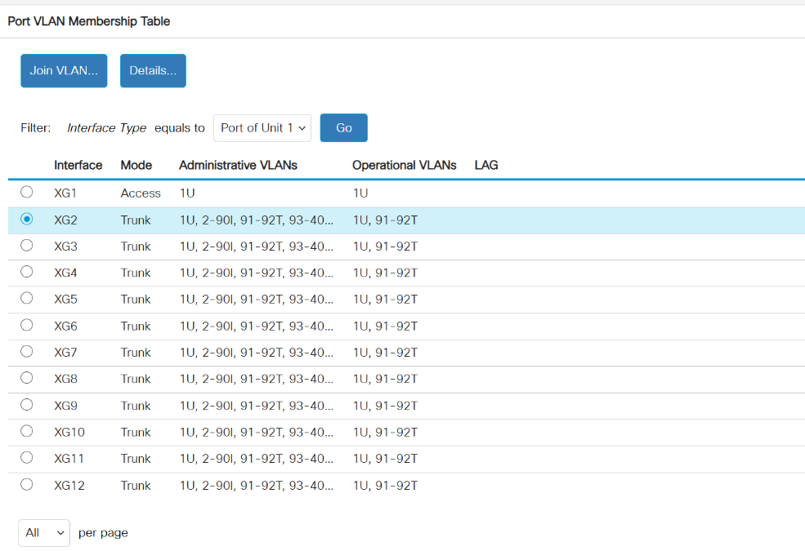
Click on the XG2 interface, then click Join VLAN…
Set the Native VLAN ID to your Data Network ID and under Tagged VLANs list your Data Network and Switch Management IDs:
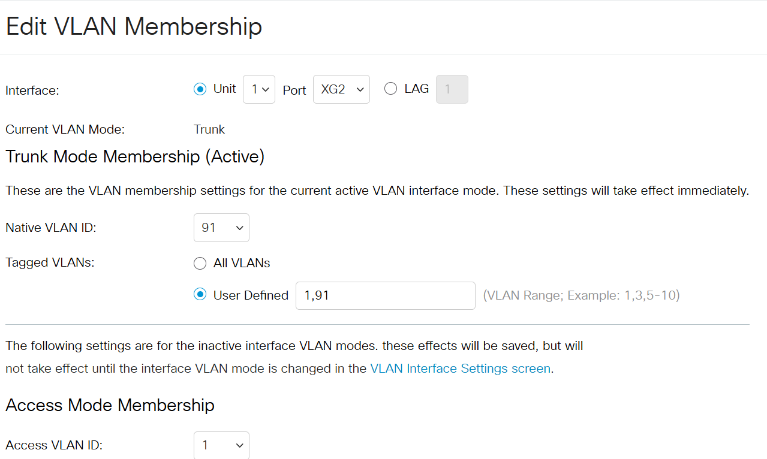
Repeat this process for ports XG3 through XG8.
Repeat this process for your Management Network VLAN as well. Refer to our table above for the correct interface ports.
CLI to accomplish this task:
configure terminal
ip dhcp excluded-address 10.0.31.1 10.0.31.10
ip dhcp pool Data_Network
network 10.0.31.0 255.255.255.0
default-router 10.0.31.254
lease 0 12

ip dhcp pool Management_Network
network 10.0.32.0 255.255.255.0
default-router 10.0.32.254
lease 0 12
interface range gigabitethernet1/0/2
switchport mode trunk
switchport trunk native vlan 31
switchport trunk allowed vlan 31,1
interface range gigabitethernet1/0/3 - 8
switchport mode trunk
switchport trunk native vlan 31
switchport trunk allowed vlan 31,1
interface range gigabitethernet1/0/2
switchport mode trunk
switchport trunk native vlan 32
switchport trunk allowed vlan 32,1
interface range gigabitethernet1/0/3 - 8
switchport mode trunk
switchport trunk native vlan 32
switchport trunk allowed vlan 32,1
write memory

ip dhcp excluded-address 10.0.32.1 10.0.32.10
https://www.cisco.com/c/en/us/td/docs/switches/lan/csbms/CBS_250_350/CLI/cbs-350-cli-.pdf

Goal 5: Hypervisor Host & Virtual Machine Setup
Our goal here is to install ESXi on a USB drive, which will require creating an image on one USB and installing ESXi on a second USB to use as a boot device.

Task 1: Create an Image
- Download Rufus and ESXi 8 ISO image (w/ VMware Tools) from Canvas.
- Connect one of the USB drives to your laptop.
- Run Rufus portable.
- Select the VMware ISO file and ensure your settings match the highlighted areas:
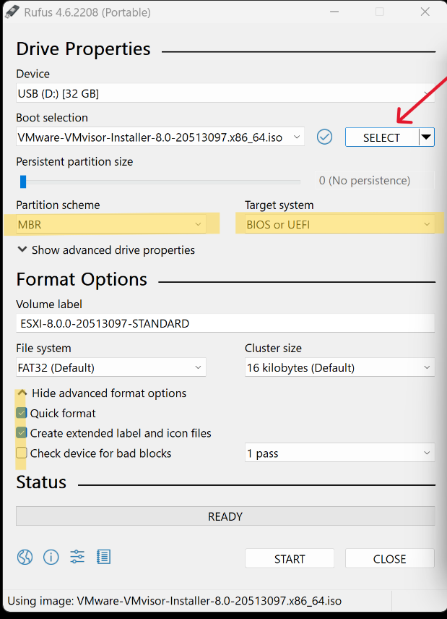
- If your menu.32 is out of date, click yes to download.
- Plug in the flash drive to the Dell server on the horizontal USB port next to the VGA plug:
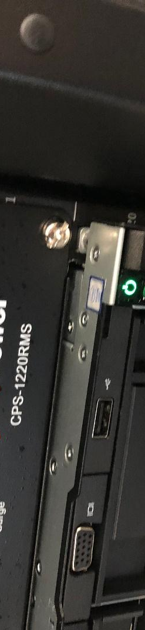
- Turn on the server. As soon as you see the Dell / EMC logo, press F11 continuously to start the Boot Manager:
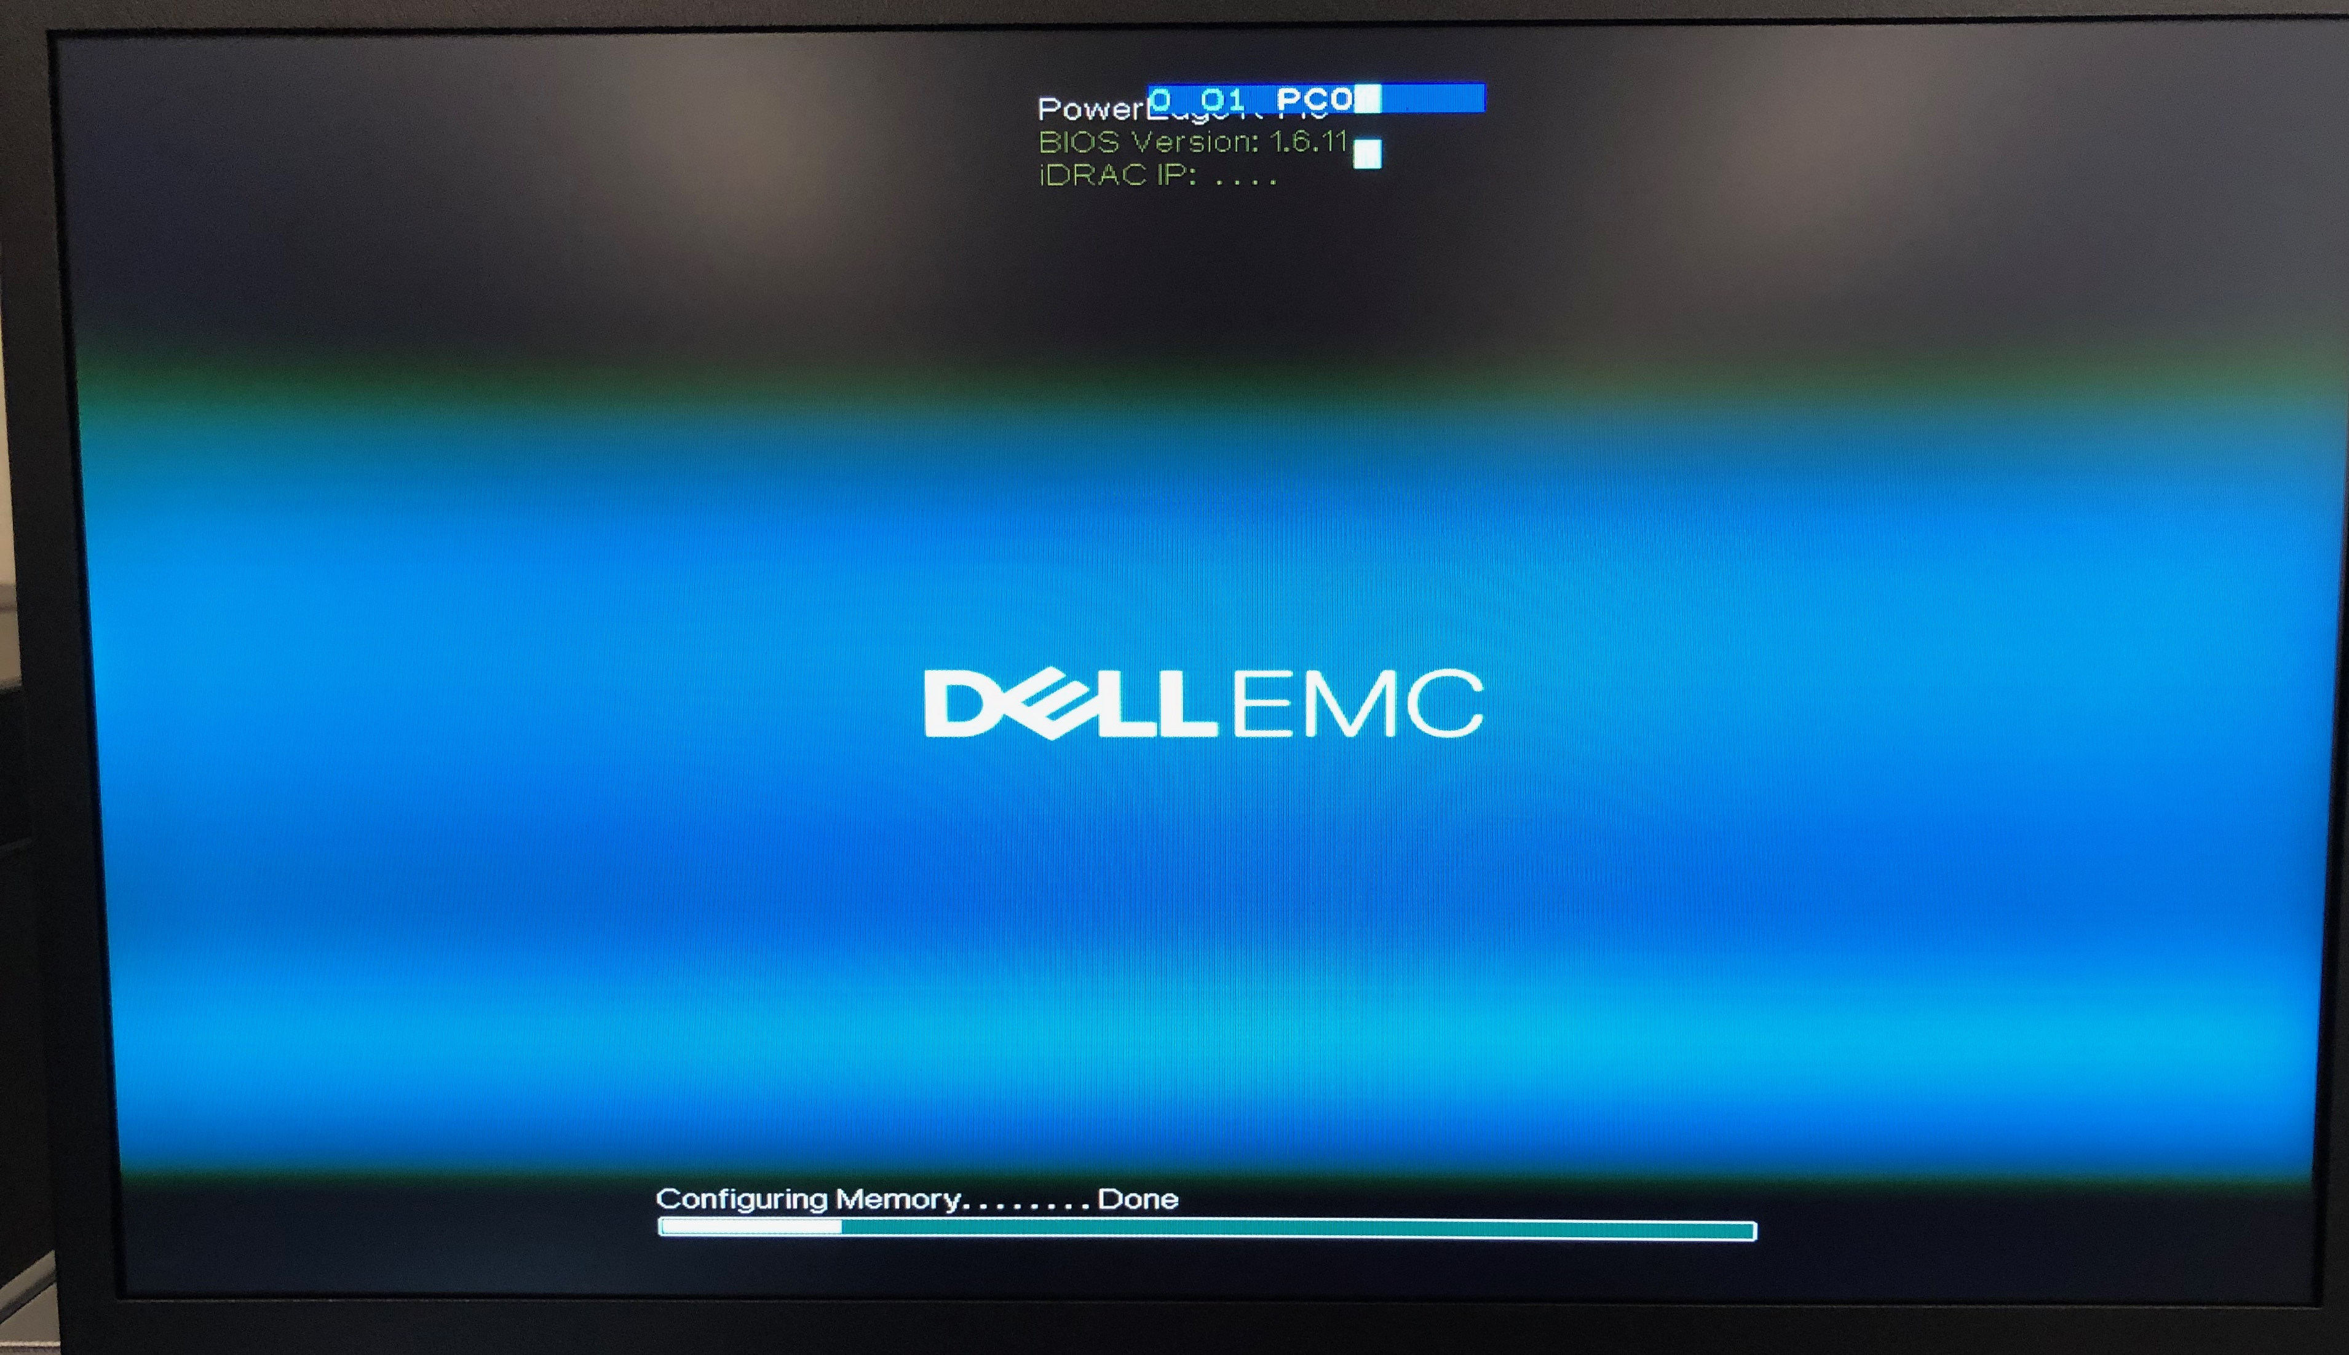
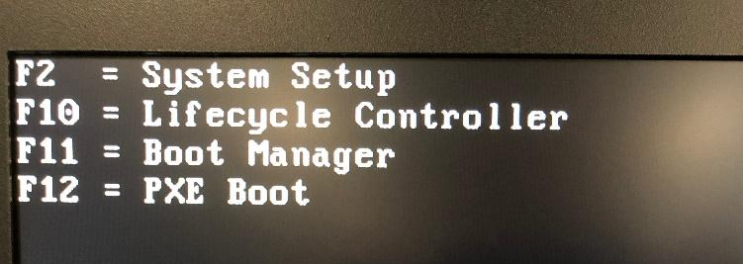
- Click on the One-shot BIOS Boot Menu.
- Click on Disk connected to front USB2.
- Select the option to boot from ESXi.
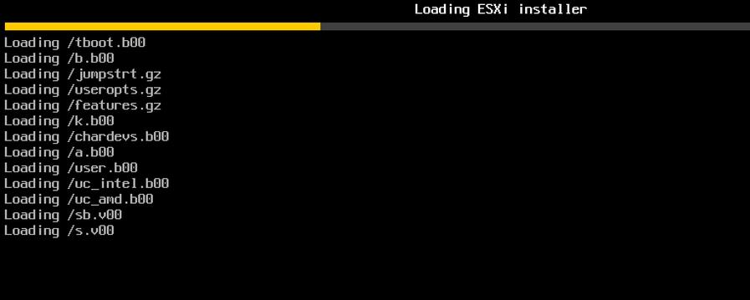
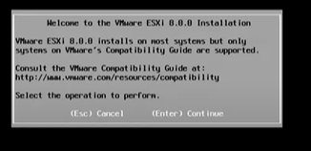
- Insert your second flash drive into the vertical USB slot.
- At the following screen select the second USB Disk, if needed hit F5 to refresh the devices:
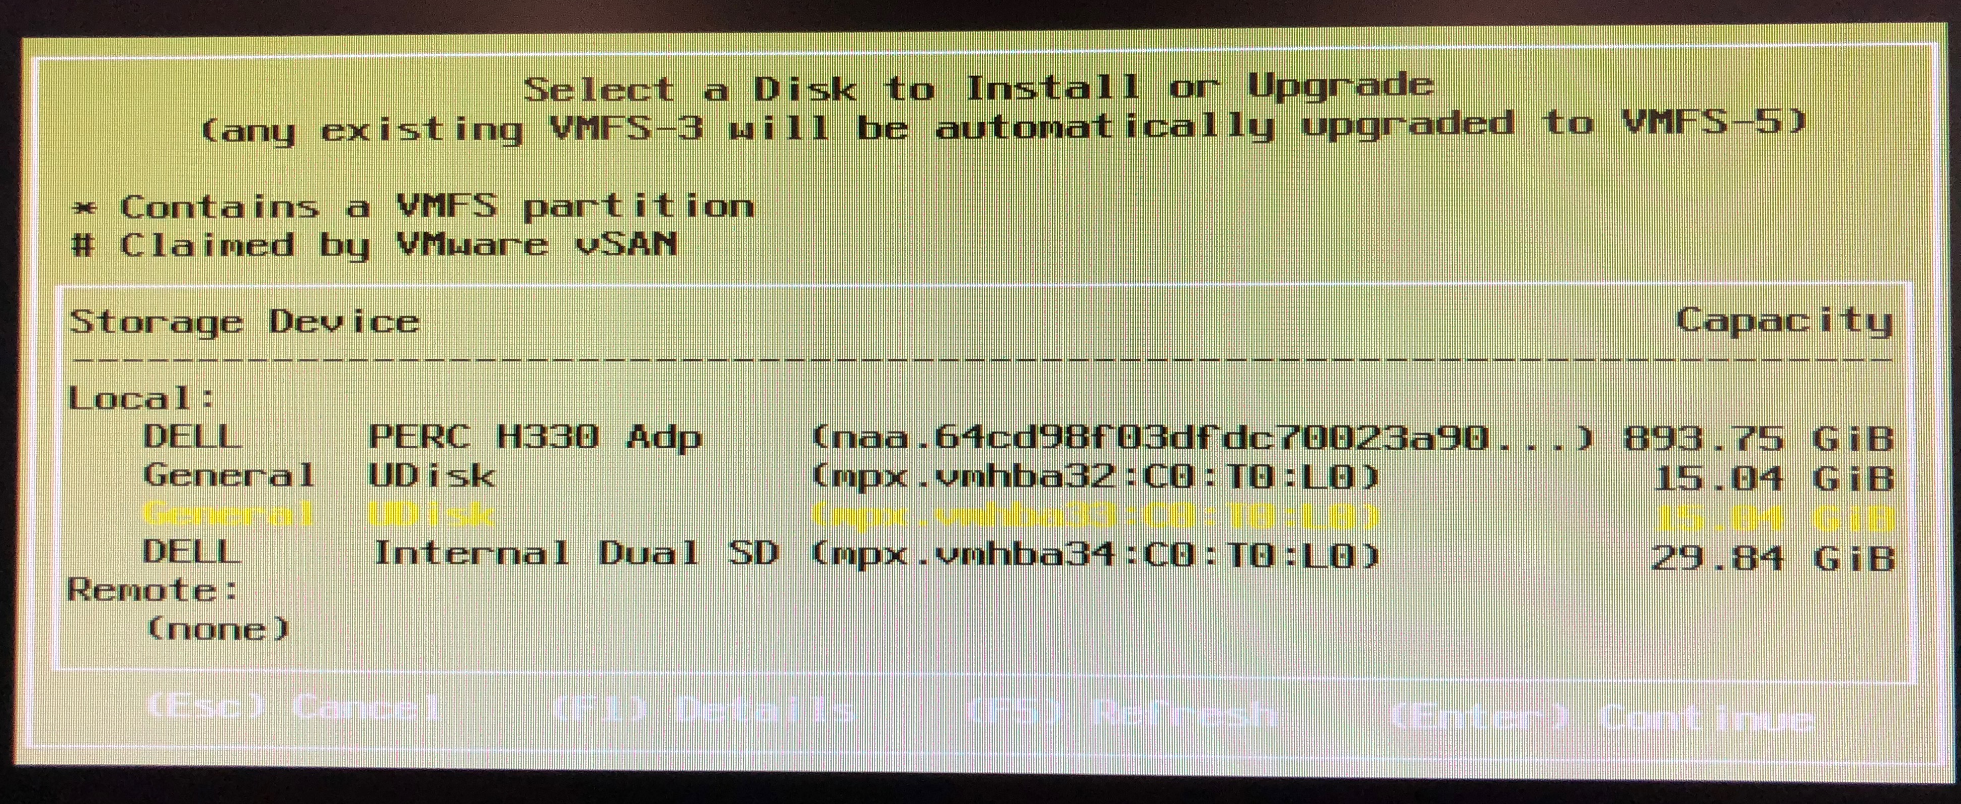
- Create a new root password: 1Panther_Geek
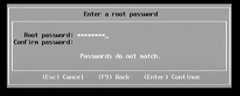
- Click F11 to install:
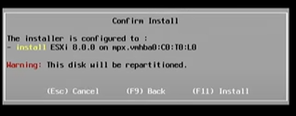
- This will install ESXi on the second USB drive.
- Once the installation is done remove the installation media (horizontal USB) and click enter to reboot the server.
- During the reboot, click F2 continuously to select the BIOS configuration menu.
- Select System BIOS.
- Select Boot Settings then BIOS Boot Settings:
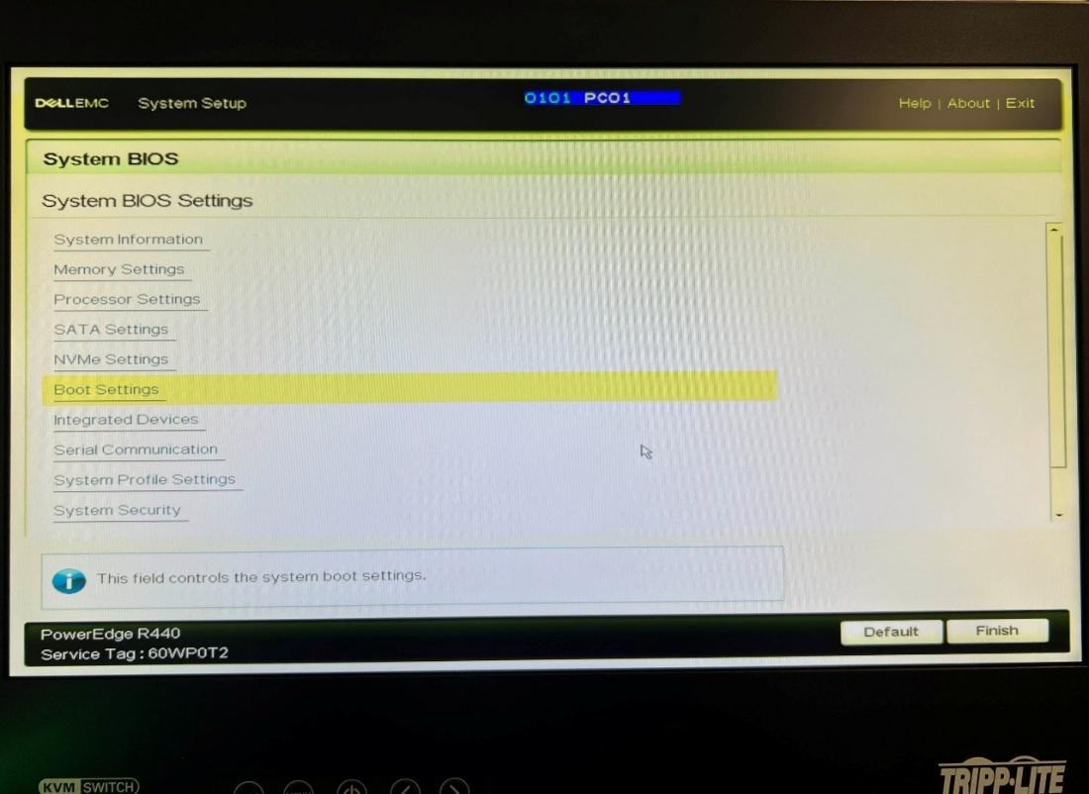
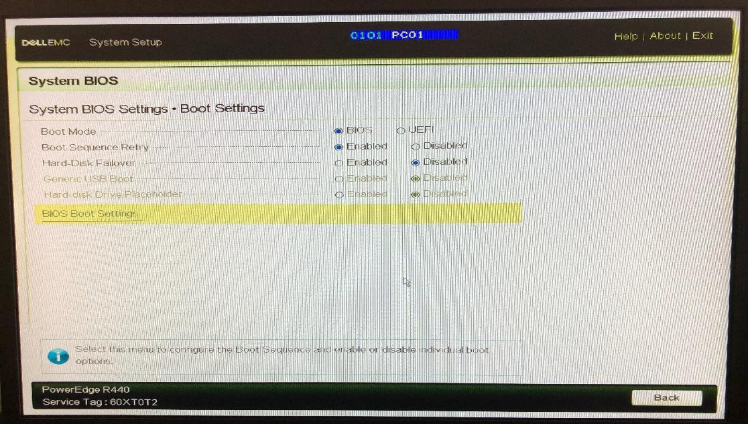
- Uncheck Embedded NIC then select Hard-Disk Drive Sequence and set USB 2 as the top priority:
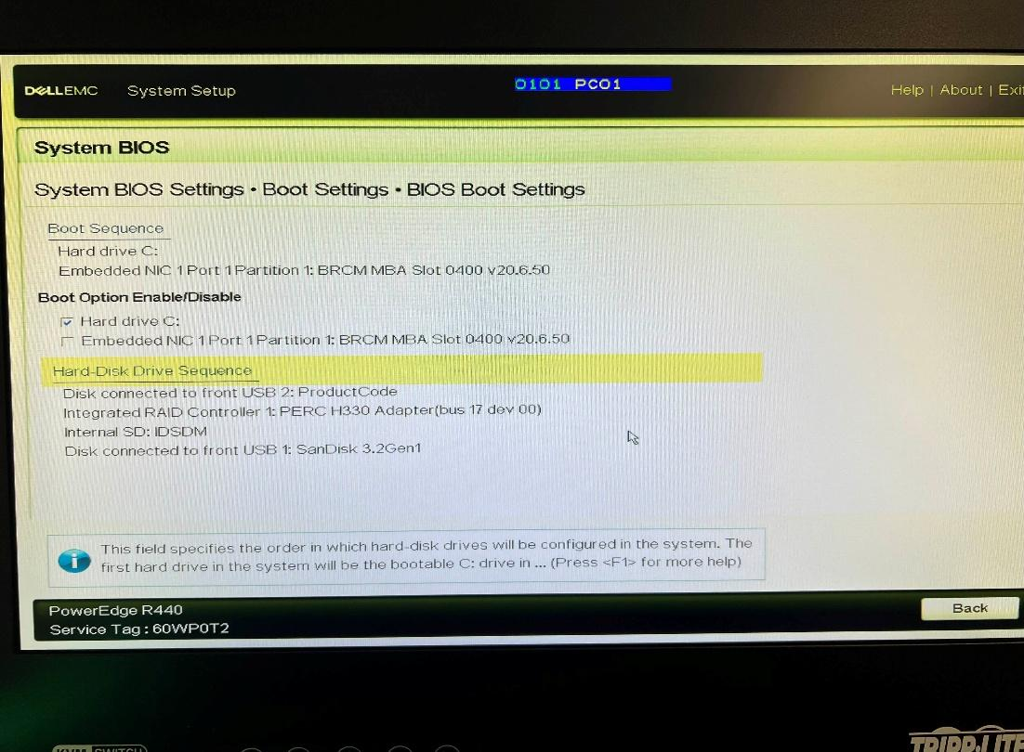
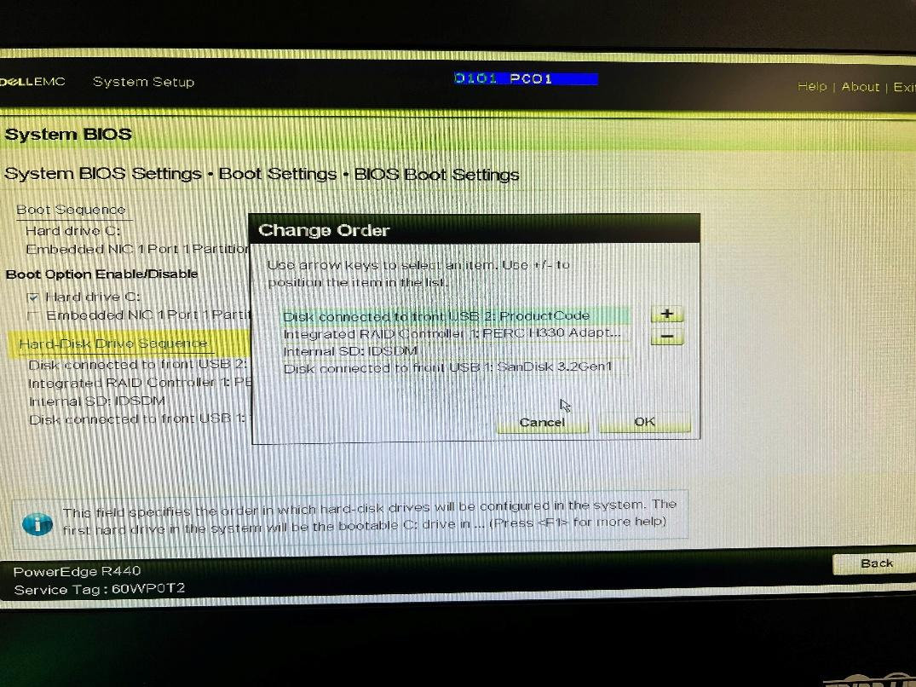

- Exit, save the changes, and confirm.
- Reboot the server and ESXi will boot off USB 2.

Task 2: Configure ESXi
- Connect the Dell Server to the Cisco switch using one of the VLAN ports we assigned to our Management Network.
- Select Customize System/View Logs:
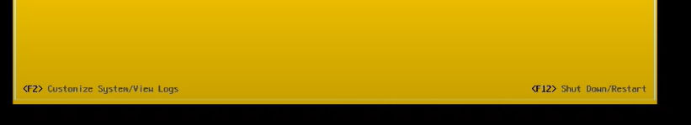
- Input your password.
- Click on Configure Management Network.
- Click Network Adapters and note the MAC address of each VMNIC.
- We will use VMNIC0 for our Management Network VLAN and VMNIC1 for our Data Network VLAN.
- Click Escape.
- Click IPv4 Configuration.
- Provide a static IP address that corresponds to your Management Network VLAN subnet.
- Connect your laptop to the switch using one of your Management Network ports.
- Connect to the at-host website using your ESXi assigned IP address and log in.

Task 3: Setup Ubuntu VM
Download the Ubuntu ISO file.
Create a new datastore:
- Select Storage on the left panel:
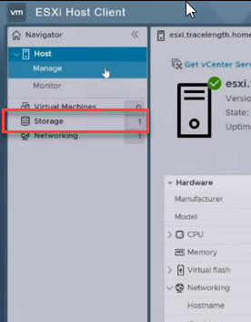
- Select New datastore so we can provision your new storage:
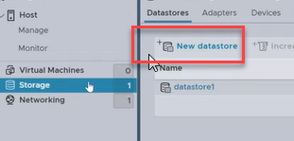
- Select Create new VMFS datastore, click next:
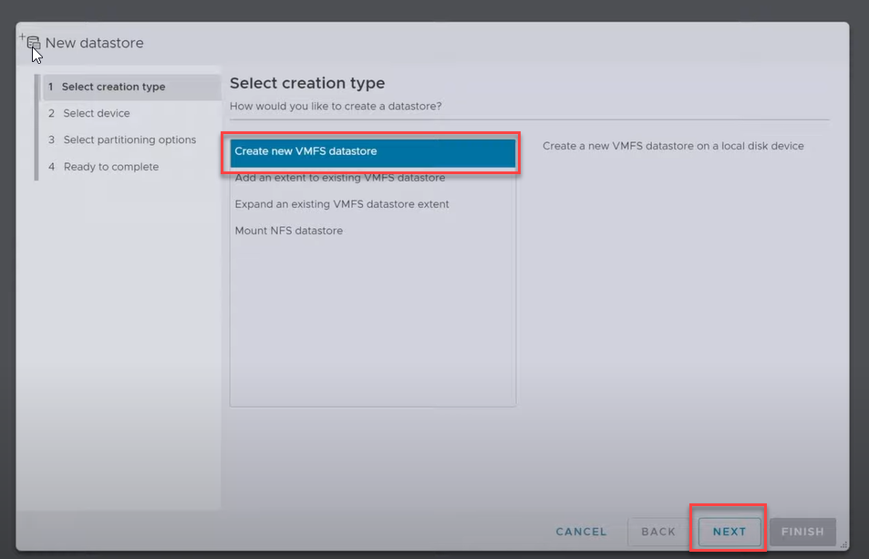
- Set Name as “DS1”, click NEXT
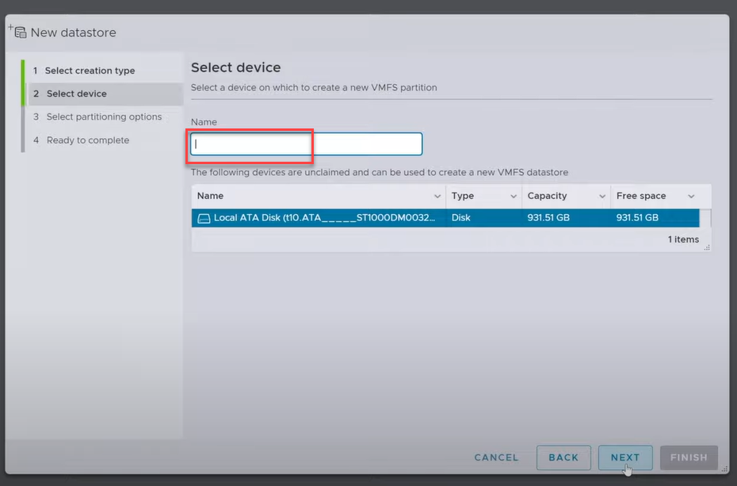
- Select Use full disk:
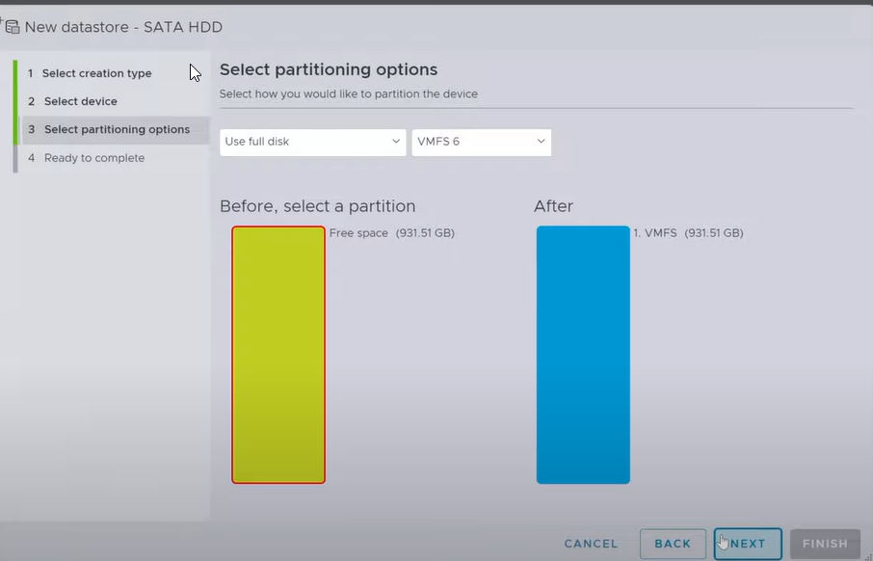
Create ISO Directory:
- With newly created datastore selected, click Datastore browser:
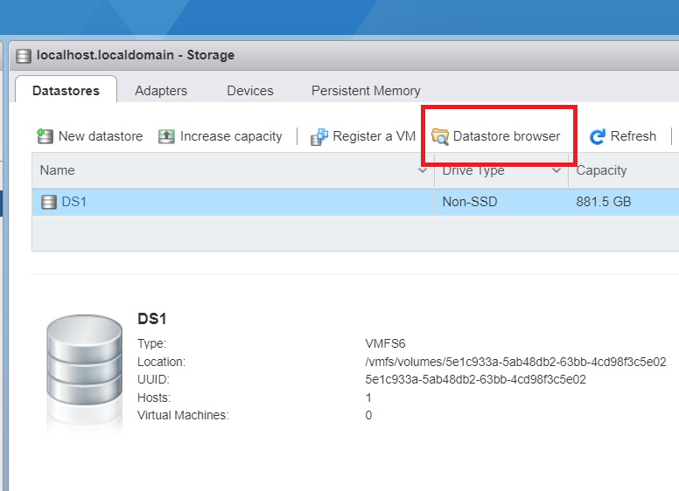
- Click Create directory:
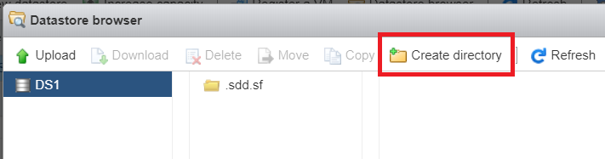
- Set Directory Name as ISO:
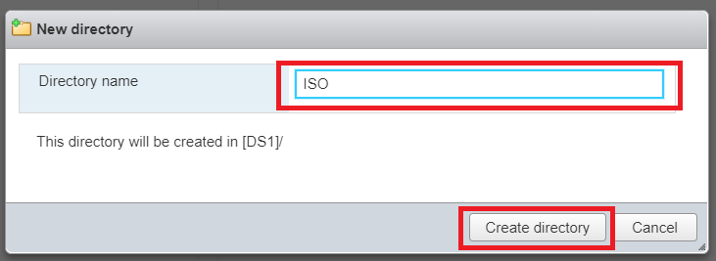
You created your ISO file directory, which is the repository where you will put all your software.
Upload the Ubuntu ISO File:
- Select Database browser:
- Upload your ISO directory:
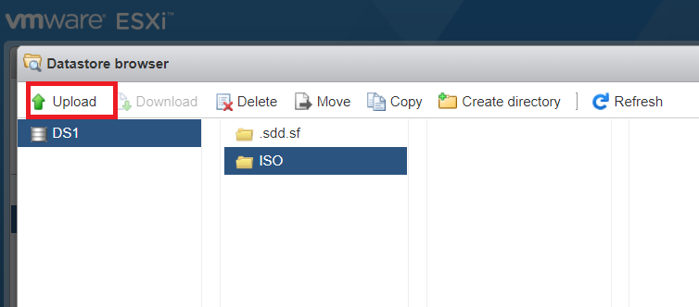
- Select the Ubuntu ISO:
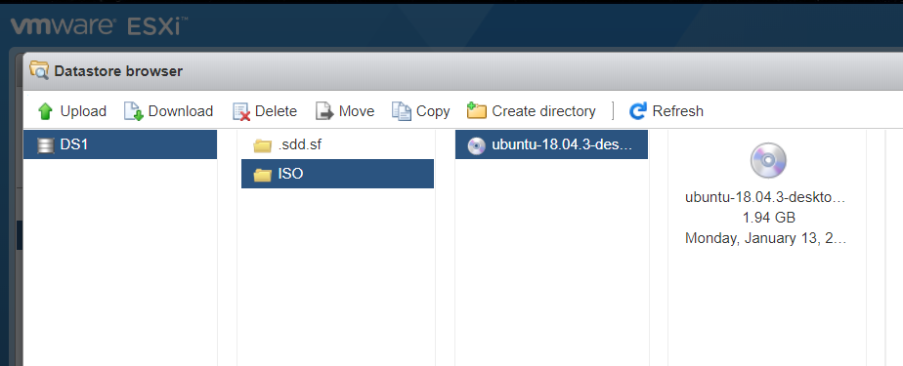
Create a new VM with Ubuntu ISO:
- Select Virtual Machines on the left panel, then click Create / Register VM:
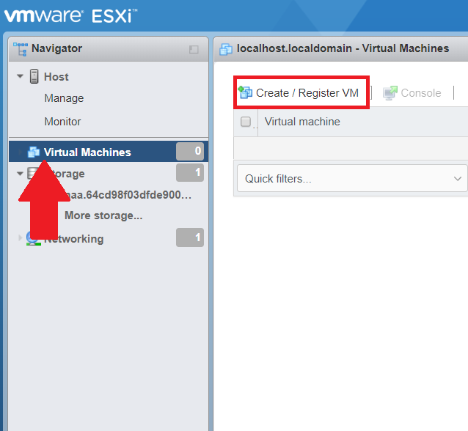
- Leave the first option selected, Click Next
- Set Name as Ubuntu with the following options selected:
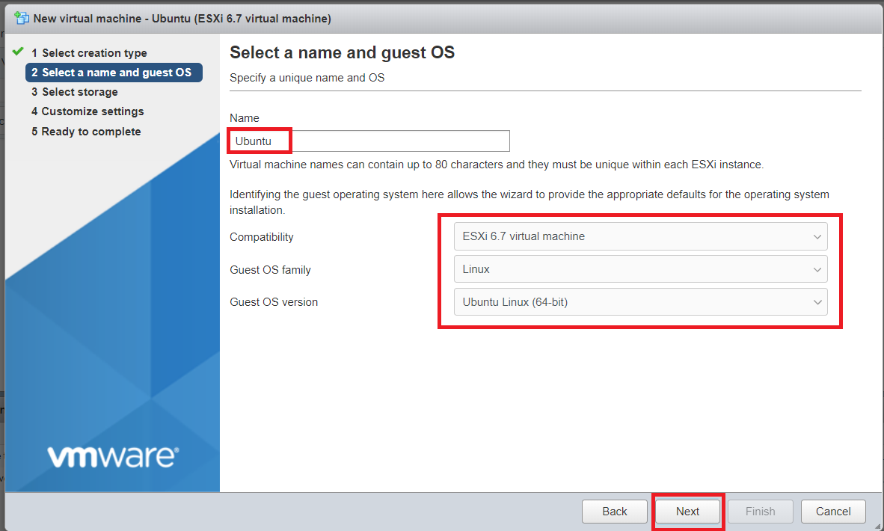
- Select the following options for the VM:
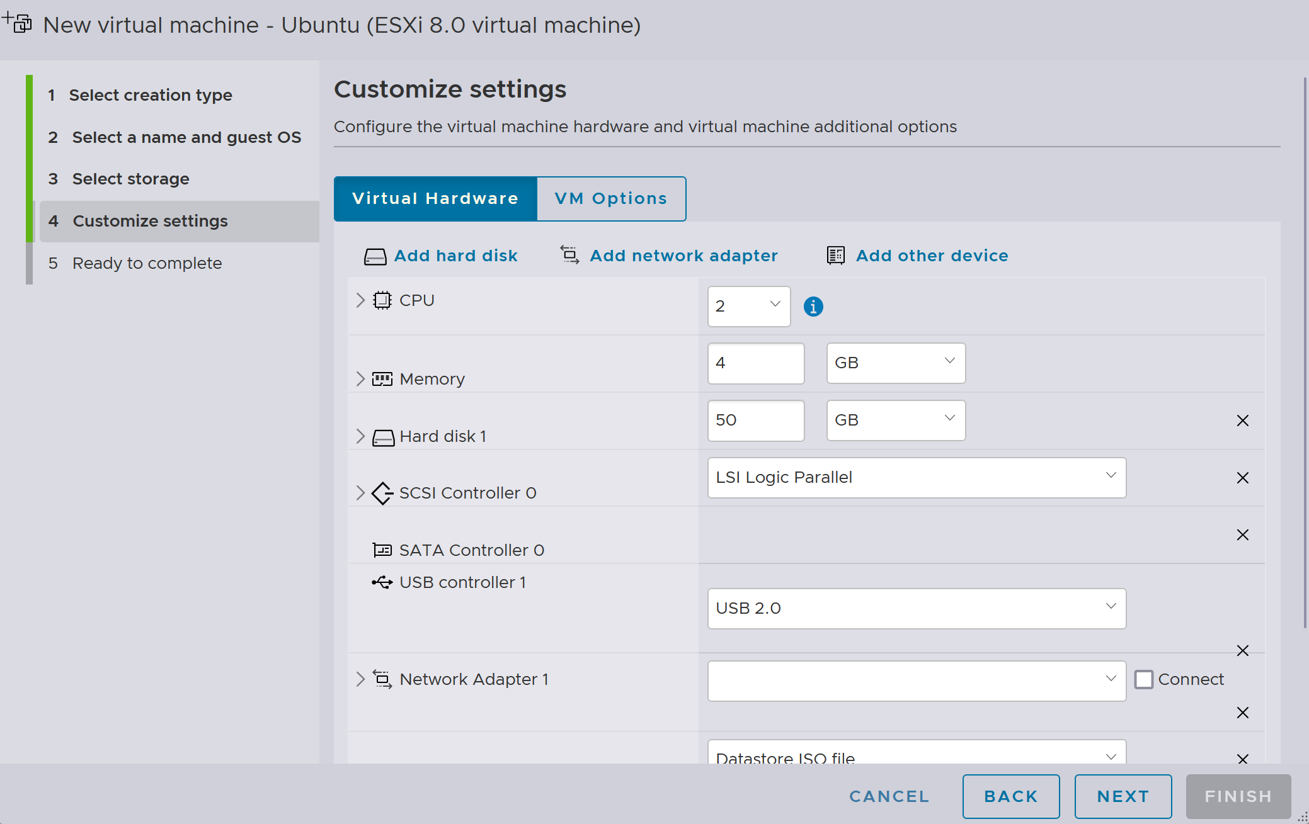
- Scroll down to the CD/DVD Drive 1 and select Datastore ISO File:
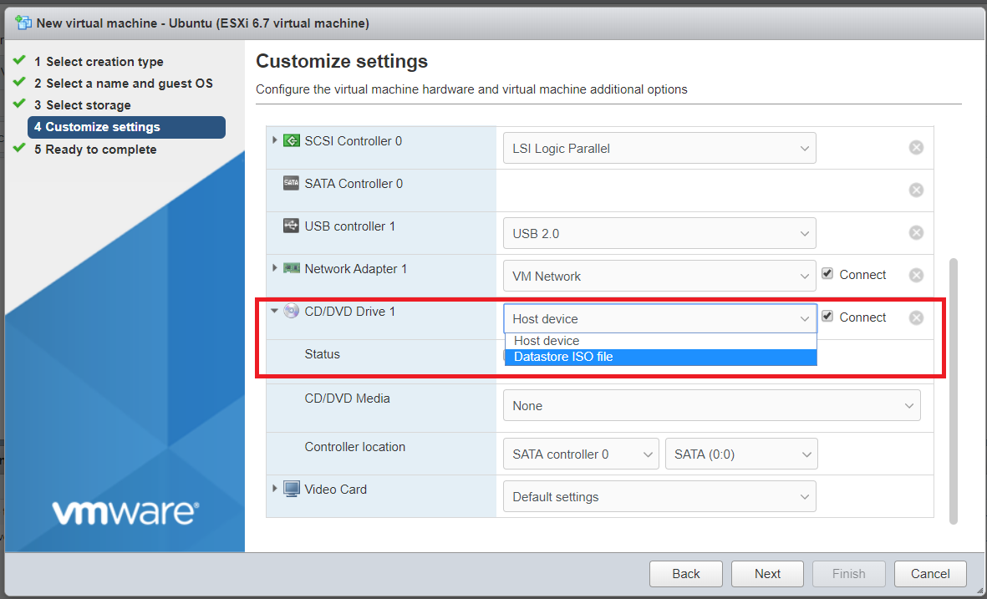
- Browse for the Ubuntu ISO you uploaded:
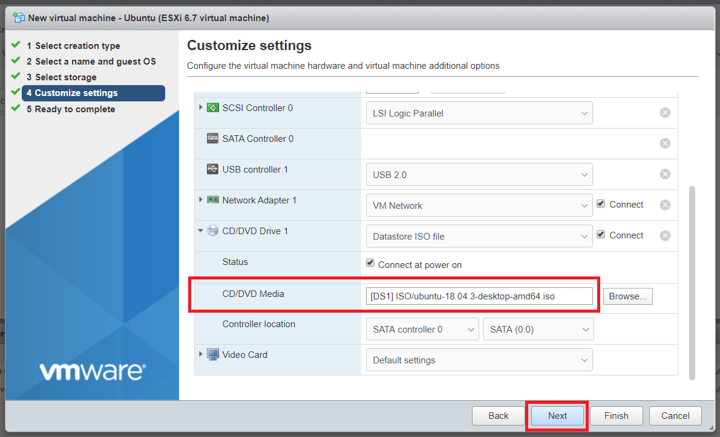
- Click Next then click Finish.
Install Ubuntu:
- On the Virtual Machines menu, power on Ubuntu:
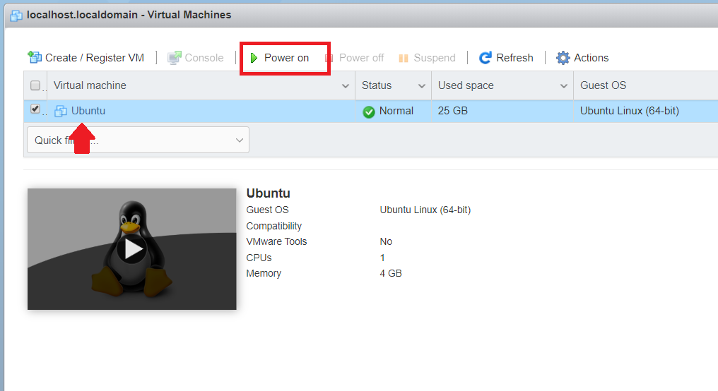
- Now install Ubuntu following the same methods you used in your Virtualization and Cloud Computing class.
Removing Installation Medium:
- After reboot, you will see the following screen:
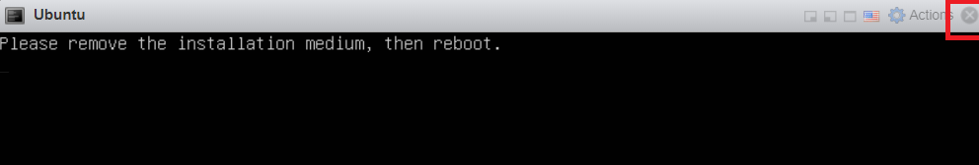
- Close the window and power off the VM.
- Right-click Ubuntu and Edit Settings.
- Reselect Host Device under your CD Drive and save the settings.

Task 3 Set up a Target FTP Server
Before starting, note that this process is insecure by design and should not be performed on a production network. FTP is an insecure protocol that sends passwords in clear text, which we will exploit to teach you how to use Wireshark to sniff network traffic.
After installing Ubuntu, power off your base Ubuntu server and clone it, ensuring you assign a unique MAC address for each cloned virtual machine.
Log into one of your VMs and test the new drive to ensure it has no issues:
https://help.ubuntu.com/stable/ubuntu-help/disk-check.html.en
Now we are going to install FileZilla, an open-source FTP application. However, because we are not connected to the internet on our VM, we cannot simply download it from a repository.
Luckily, the solution is simple: we can use a flash drive. Start by adding a USB device to our Ubuntu VM:
- Plug an unused USB drive into the horizontal USB port on the Dell Server.
- Back on ESXi, under Virtual Machines, select Ubuntu.
- Click on Actions then Edit Settings:
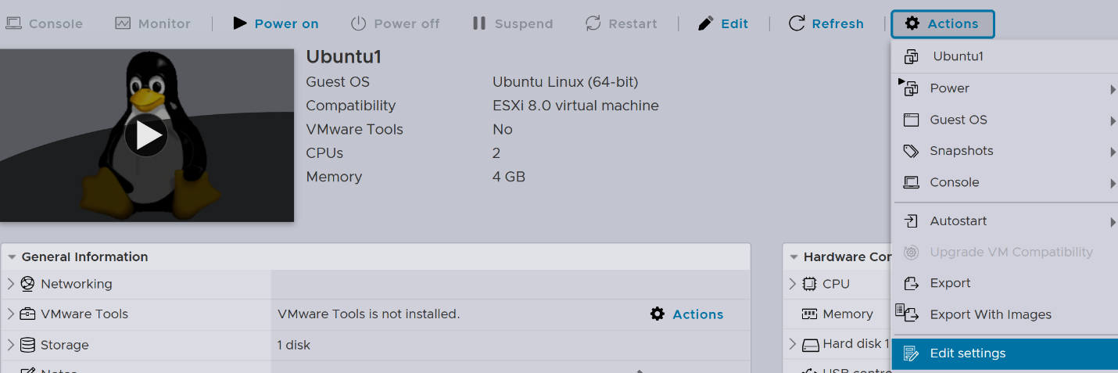
- Then click on Add Another Device followed by USB device.
- Select your USB drive.
- Disconnect your flash drive and plug it into your personal laptop.
- Download the FileZilla Linux 64bit .deb file.
- Reconnect the drive to the Dell Server using the horizontal USB slot.
- Start Ubuntu and place the .deb file on your desktop.
- Fire up a terminal window and use the following command:
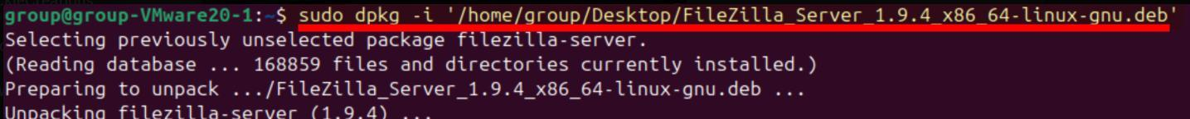
You can check your dash menu to confirm FileZilla was unpacked correctly:
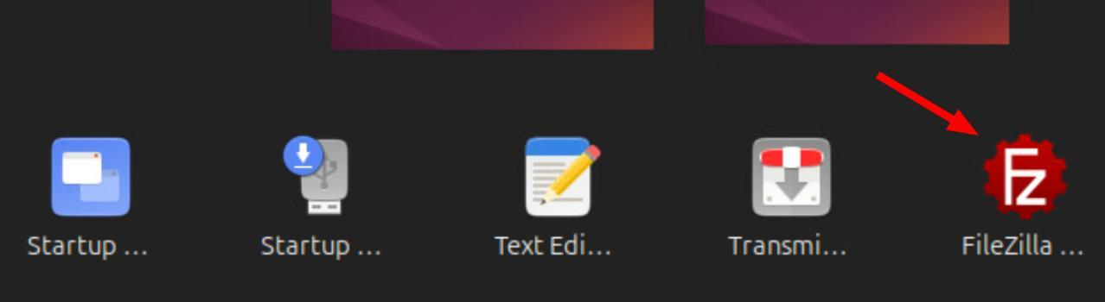

Task 4 Setup Vulnerable Pi
- Download RasPwn OS and install it on to your second Raspberry Pi.
- Configure it plug into your switch using a Data Network port.
Under no circumstance do you plug this Raspberry Pi into the campus network.

Task 5: Sniff & Analyze Traffic
- Setup Windows Sandbox mode on your laptop: Windows Sandbox - Windows Security | Microsoft Learn
- Connect your laptop and start command line from the sandbox of windows.
- Next start Wireshark.
- Start a capture in Wireshark.
- Connect to your FTP Server using the CLI:
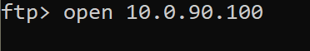
- Input your ftp username and password.
- Stop the capture in Wireshark.
- Filter for ftp.
- In the list of packets, look for the unencrypted username and password.
- Open FTP, begin sniffing, and transfer the Linux password file you copied in the last task.
- Provide screenshots of you analyzing traffic, identifying threats such exfiltration of usernames and passwords and correlate data to identify vulnerability and recommendation.
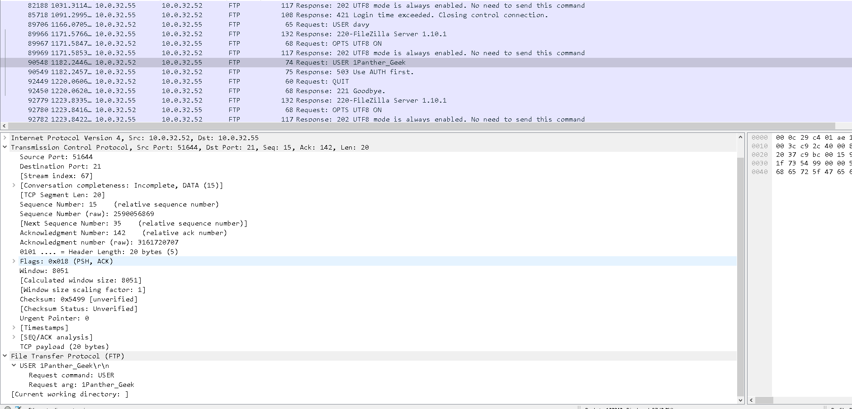

Goal 6: Scan Another Team’s Infrastructure

Task 1: Install Greenbone and Run a Test Scan
Install Greenbone on your Kali VM. The steps are the same as those you completed in your Virtualization and Cloud Computing course hypervisor project.
Conduct a test scan on your network, patch any vulnerability you find.
Show your instructor.

Task 2: Scan Another Team’s Infrastructure
For the next step, please check with the instructor first so the instructor can assign you another group to scan.
- Once assigned, conduct a credentialed scan on your target network.
  - Provide the results to your instructor so you can submit to Canvas.
  - Extract the scan results so you can submit your final project.
- To extract the CVEs during your scans, look under the SecInfo tab.
- If you ran out of time, please ask the instructor for a sample xml file that contains all the CVEs from a vulnerable Raspberry Pi.
Please ensure your report contains at least 5 CVEs, the link to the CVE details online, and potential mitigation to them.
- Please see Canvas for turn in details of The Engagement: Assessment Report.
- Patch all your systems and conduct a scan again to compare your results.

Goal 7: Tools of the Trade
The following tools provide essential capabilities for penetration testing and security assessments, enabling tasks like network analysis, wireless auditing, and hardware exploitation in a controlled environment:
- Signal Owl: A compact Wi-Fi auditing tool for network reconnaissance and exploitation.
- Bash Bunny: A versatile USB attack platform for automating advanced penetration testing.
- Wi-Fi Pineapple Tetra: A powerful Wi-Fi penetration testing device for monitoring and exploiting wireless networks.
- Lan Turtle: A covert USB Ethernet adapter for network intrusion and remote access.
- HackRF One: A software-defined radio platform for wireless signal analysis and experimentation.
- Keysy w/ Rewriteable Key Fobs: A device for cloning and emulating RFID-based access control systems.
- GreatFET One: A general-purpose USB tool for hardware hacking and debugging.
- Ubertooth One: A tool for Bluetooth sniffing and security analysis.
- O.MG Cable: A malicious USB cable capable of exfiltration and payload delivery.
- Screen Crab: A stealthy device for capturing and transmitting HDMI screen output.
- Alfa AWUS036ACM Long-Range Dual-Band: A USB Wi-Fi adapter for extended-range wireless penetration testing.
- AWUS036NH High Gain USB Wireless: A USB Wi-Fi adapter optimized for long-range wireless signal analysis.
- Anker PowerCore (or similar): A portable power bank for powering devices during field operations.
- WiFi Nano Tactical (or similar): A compact wireless adapter designed for portable network testing.
- RALINK (or similar): A USB Wi-Fi adapter known for compatibility with wireless penetration tools.

Goal 8: Expanded Cyber Range
A separate lab manual is provided on Canvas for each of these tasks, the listing below provides a summary.

Task 1 Setup Windows Services
- Gain Access to Microsoft Imagine w/ licenses for Windows (see instructor)
- Windows 11
  - Download windows 11
  - Install it as a VM on ESXi
  - Hack the local password per the “windows password hacking” lab document in Canvas
- Setup 3 windows servers (lookup instructions online)
  - Server 1: Domain Controller
  - Server 2: SMB file share
  - Server 3: Web server
  - Server 4: Windows Certificate Services
  - PC 1: Windows 10 domain client
  - PC2: Windows 10 domain client

Task 2 Setup Unix Services
- Services (on your own)
- Setup Nagios and setup monitoring on your network
- Setup a syslog using Splunk
- Setup an Ubuntu OWASP web server
- Setup an Ubuntu File FTP Server
- Setup an Ubuntu Router
- Setup snort on an Ubuntu OS
- Firewall
Setup Smoothwall firewall:
- The goal here is to create a segregated network for a secure system later.
- Download Smoothwall, load the ISO to a VM and 3 VMNICS.
- Select express install.
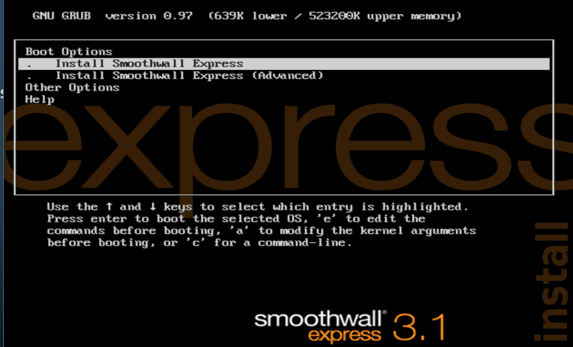
- Click ok.
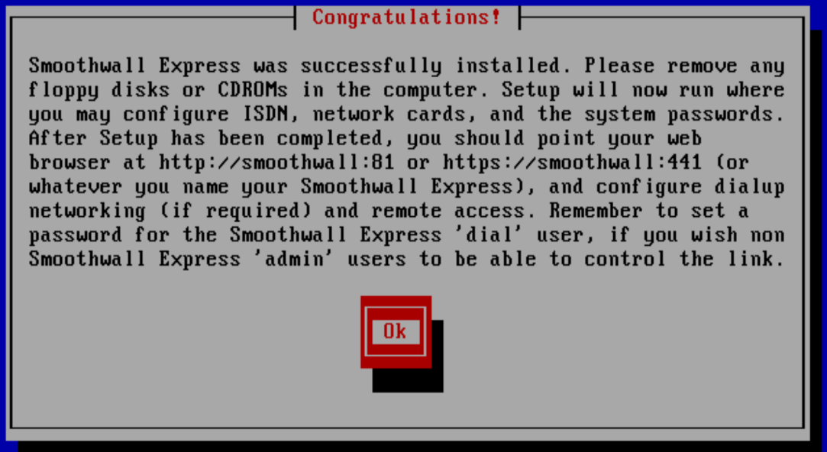
- Select the configuration for half open
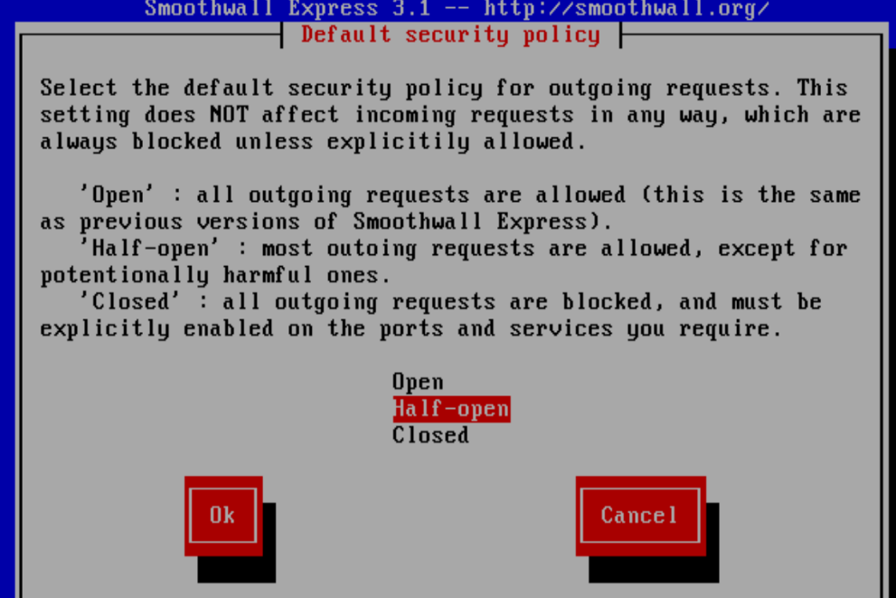
- Select GREEN + RED.
- GREE is for outbound traffic, and RED is for inbound traffic.
- Note the MAC address on both: Click or tap here to enter text.
- Configure static IPs (the inbound IP, from your LAN) (10.0.##.xxxx):
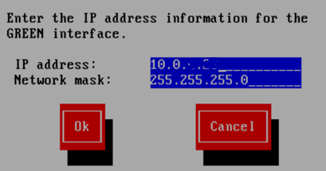
- Then configure Smoothwall for an outbound IP.
- Skip the rest of the settings for now and turn off the VM.
- Network all devices.

Task 3: Setup OWASP web server
Setup an OWASP webserver on VLAN 7 in your ESXI : https://www.owasp.org/index.php/OWASP_Broken_Web_Applications_Project
Here is how you can trunk the traffic:
- Ensure the VM is tagged as VLAN 7 on the hypervisor:
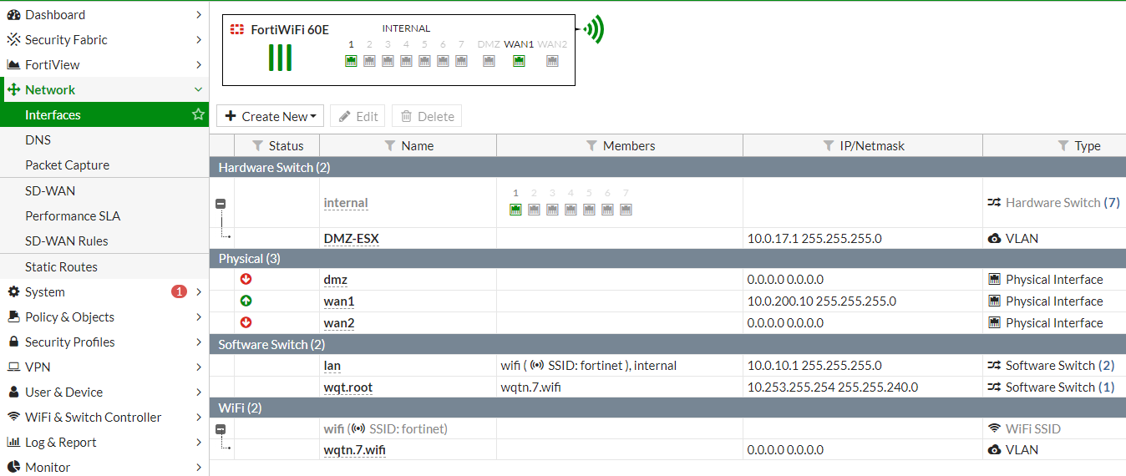
- Configure the firewall for a DMZ interface.
- Switch config using rack 1 as an example:
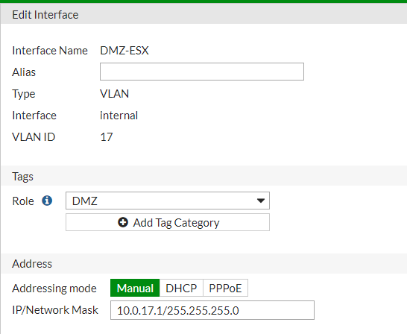
- Access the webserver to verify its up.

Task 4 Setup Mobile & IOT Devices
- Wi-Fi:
  - Setup Wi-Fi___33 with two networks, BYOD/IOT and business.
  - Use WPA2 or better security.
- Devices:
  - Add at least one IOT Device.
  - Install DIVA on an IPAD, conduct a scan and turn in your results.

Task 5: DMZ Setup (Extra Credit)
Using the assigned Raspberry Pi, set up a web server. Connect your Pi to lan3 and configure a DMZ. Create a complete step-by-step guide and turn it in.

Task 6: VPN (Extra Credit)
Set up an SSL VPN tunnel between your network and the other teams’ network.

Task 7: VPN with 2 factor authentication (Extra Credit)
Configure your SSL VPN tunnel to use 2FA with FortiKeys. Team up with another Rack to research this step.

Task 8: Expanded Scan of Your network.
After setting up OWASP, IOT, & additional systems, run another GVM scan on the expanded infrastructure.

References
Cisco Business Switch 350 CLI Index: https://www.cisco.com/c/en/us/td/docs/switches/lan/csbms/CBS_250_350/CLI/cbs-350-cli-/cbs-350-cli-_CLT_chapter.html
Cisco CBS350 Administration Guide
https://www.cisco.com/c/en/us/td/docs/switches/lan/csbms/CBS_250_350/Administration-Guide/cbs-350.pdf
Fortinet Documentation Home
https://docs.fortinet.com/
FortiGate 6.2 Documentation
https://docs.fortinet.com/product/Fortigate/6.2
Fortinet CLI Help (FOS 6.0)
https://help.fortinet.com/cli/fos60hlp/60/index.htm
Offensive Security Website
https://www.offensive-security.com/
VMware vSphere Documentation
https://docs.vmware.com/en/VMware-vSphere/index.html

Contributors / Testers
The following people have contributed to this Lab manual.
Name | Contribution
Phil Jackson  John Coke  Nick Little  Adi Tuhuteru  Lindsey Slakter  Gabriel Goltz  Lindsey Slakter  Gabriel Goltz | Testing  Testing  Identified bug in switch and found fix  Identified a missing command switch  Author v0.6.0  Author v0.6.0  Author v0.6.1  Author v0.6.1

